Propagation of uncertainty
A student wants to determine the angular speed ω of a rotating object. The period T is 0.50 s ±5 %. The angular speed ω is
ω=2πT. What is the percentage uncertainty of ω?
A. 0.2 %
B. 2.5 %
C. 5 %
D. 10 %

Power of magnitude
Scale drawing to find resultant vector
Magnitude and direction
Trigonometry to find resultant vector
Magnitude and direction
Pythagorean Law and tanθ=O/A
Average speed vs average displacement
A car moves north at a constant speed of 3m s–1 for 20s and then east at a constant speed of 4m s–1 for 20s. What is the average speed of the car during this motion?
A. 7.0m s–1
B. 5.0m s–1
C. 3.5m s–1
D. 2.5m s–1

Graph
Area of a-t v-t
Find area of triangle/trapezoid
Positive and negative area
The variation with time t of the acceleration a of an object is shown.

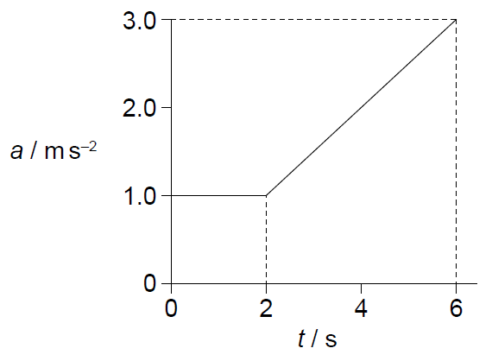
What is the change in velocity of the object from t = 0 to t = 6 s?
A. 6 m s–1
B. 8 m s–1
C. 10 m s–1
D. 14 m s–1

Gradient of s-t v-t
Find gradient of tangent line
Positive and negative gradient
An object is thrown upwards. The graph shows the variation with time t of the velocity v of the object.
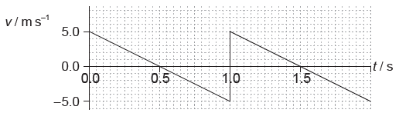
What is the total displacement at a time of 1.5 s, measured from the point of release?
A. 0 m
B. 1.25 m
C. 2.50 m
D. 3.75 m

Converting graphs
The graph shows how the position of an object varies with time in the interval from 0 to 3 s.
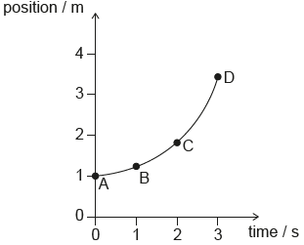
At which point does the instantaneous speed of the object equal its average speed over the interval from 0 to 3 s?
The graph shows the variation of velocity of a body with time along a straight line.

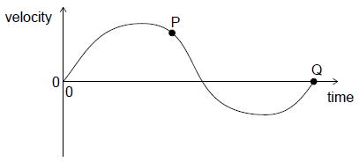
What is correct for this graph?
A. The maximum acceleration is at P.
B. The average acceleration of the body is given by the area enclosed by the graph and time axis.
C. The maximum displacement is at Q.
D. The total displacement of the body is given by the area enclosed by the graph and time axis.

Free fall
Fall as a=g
Falling with air resistance
a:max at start, then decrease to 0
v: 0 at start, then increase with a decreasing rate
Terminal speed when f=mg
An object of weight W is falling vertically at a constant speed in a fluid. What is the magnitude of the drag force acting on the object?
A. 0
B. W2W2
C. W
D. 2W
An aircraft is moving horizontally. A parachutist leaves the aircraft and a few seconds later opens her parachute. Which graph shows the variation of the vertical speed v with time t for the parachutist from the time she leaves the aircraft until just before landing?

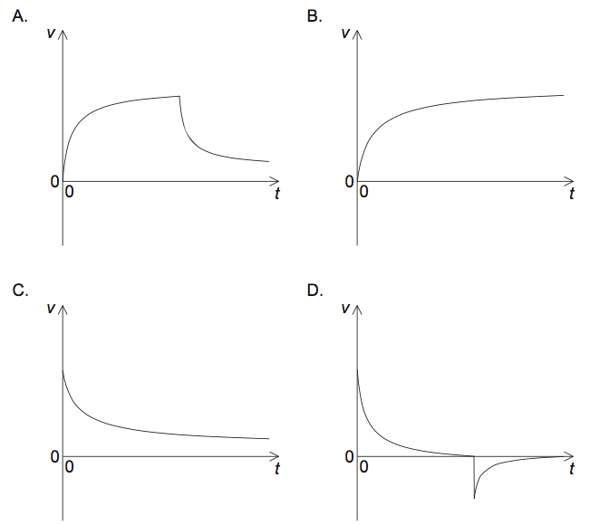

Relative v
A to B v=v_{A}-v_{B}
Change of v=v_{f}-v_{i}

