TOPIC 2 ATOMIC STRUCTURE
2.1 The nuclear atom
Learning objectives
- Understand that an atom is made up of protons, neutrons and electrons
- Define mass number, atomic number and isotope
- Work out the numbers of protons, neutrons and electrons in atoms and ions
- Discuss the properties of isotopes
- Calculate relative atomic masses and abundances of isotopes
- Understand that a mass spectrometer can be used to determine the isotopic composition of a sample
The atom
The word ‘atom’ comes from the Greek words for ‘not able to be cut’. Dalton was the first person to assign chemical symbols to the different elements. John Dalton (1766–1844) is generally regarded as the founder of modern atomic theory.
In the simplest picture of the atom the negatively charged electrons orbit around the central, positively charged nucleus. The nucleus is made up of protons and neutrons (except for a hydrogen atom, which has no neutrons).
Protons and neutrons, the particles that make up the nucleus, are sometimes called nucleons. The actual mass of a proton is 1.67 × 10⁻²⁷ kg and the charge on a proton is +1.6 × 10⁻¹⁹ C.
Relative masses and charges, shown in Table below are used to compare the masses of particles more easily and have no units.
Particle | Relative mass | Relative charge
Proton | 1 | +1
Neutron | 1 | 0
Electron | 5.0 x 10⁻⁴ | -1
The mass of an electron is often regarded as negligible.
Most of the mass is concentrated in the nucleus. However, most of the volume of the atom is due to the electrons – the nucleus is very small compared with the total size of the atom.
NATURE OF SCIENCE: Dalton’s atomic theory was not accepted when it was ﬁrst proposed. Many scientists, such as Kelvin for example, considered it as nothing more than a useful ﬁction which should not be taken too seriously. Over time, as the supporting evidence grew, there was a general shift in thinking which led to its widespread acceptance. These revolutions in understanding or ‘paradigm shifts’ are characteristic of the evolutions of scientiﬁc thinking.
Where to place the mass number (A) and atomic number (Z) in the full symbol of an element X
A
X= Element symbol
A= Mass number, Z= Atomic number

_{Z} X
23
For example sodium: ₁₁ Na
Atomic number (Z) is the number of protons in the nucleus of an atom.
The atomic number (Z) defines an element – it is unique to that particular element. For example, the element with atomic number 12 is carbon and that with atomic number 79 is gold.
Mass number (A) is the number of protons plus neutrons in the nucleus of an atom. It is sometimes called the nucleon number.
So, number of neutrons in an atom = mass number − atomic number
Ions
Ions are charged particles that are formed when an atom loses or gains (an) electron(s).
A positive ion (cation) is formed when an atom loses (an) electron(s) so that the ion has more protons (+) than electrons (−). A negative ion (anion) is formed when an atom gains (an) electron(s) so that the ion has more electrons (−) than protons (+).
Isotopes: How can an element have a fractional relative atomic mass if both the proton and neutron have a relative mass of 1?
One reason is that atoms of the same element with different mass numbers exist, so it is necessary to work within an average value. Isotopes are different atoms of the same element with different mass numbers. They have different number of neutrons.
Isotopes have the same chemical properties (they react in exactly the same way because they have same number of electrons) but different physical properties (e.g. different melting points and boiling points).
Solve the following:
- Identify the sub-atomic particles present in an atom of ²²⁶Ra.

- Most nutrient elements in food are present in the form of ions. The calcium ion ⁴⁰Ca²⁺, for example, is essential for healthy teeth and bones. Identify the sub-atomic particles present in the ion.

- Identify the species with 19 protons, 20 neutrons and 18 electrons.

Relative atomic masses
An instrument known as a mass spectrometer can be used to measure the mass of individual atoms. The mass of a hydrogen atom is 1.67 × 10^{–24} g and that of a carbon atom is 1.99 × 10^{–23} g. these numbers are beyond our direct experience, it makes more sense to use relative values. Also, because of the different isotopes present, it is most convenient to quote an average mass for an atom.
The relative atomic mass (Ar) of an element is the average of the masses of the isotopes in a naturally occurring sample of the element relative to the mass of $\frac{1}{12}$ an atom of carbon-12.
Mass spectra
The results of the analysis by the mass spectrometer are presented in the form of a mass spectrum. The horizontal axis shows the mass/charge ratio of the different ions on the carbon-12 scale, which in most cases can be considered equivalent to their mass. The percentage abundance of the ions is shown on the vertical scale.
Mass spectrum for gallium. The number of lines indicates the number of isotopes (two in this case), the value on the x-axis indicates their mass number (69 and 71) and the y-axis shows the
Percentage abundance.

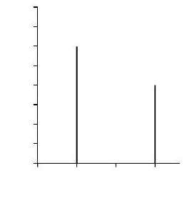
% abundance
80
70
60
50
40
30
20
10
0
69
70
mass/charge
71
Relative atomic mass = $\frac{\left(69 × 60\right)+(71× 40) }{100}$ = 69.80

- Deduce the relative atomic mass of the element rubidium from the data given in Figure

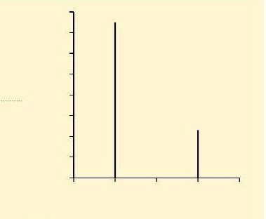
% abundance
80
70
60
50
40
77
30
20
10
0
23
85
86
mass/charge
87 88

- Lithium has two naturally occurring isotopes: ⁶Li: natural abundance 7% and ⁷Li: natural abundance 93%. Calculate the relative atomic mass of lithium.

- Boron exists in two isotopic forms, ¹⁰B and ¹¹B. ¹⁰B is used as a control for nuclear reactors. Use your Periodic Table to find the abundances of the two isotopes.

- Iridium has a relative atomic mass of 192.22 and consists of Ir-191 and Ir-193 isotopes. Calculate the percentage composition of a naturally occurring sample of iridium.

