7 Equilibrium
Learning objectives
- Understand that a reversible reaction can come to a state of equilibrium
- Explain what is meant by dynamic equilibrium
7.1.1 Reversible reactions
Reversible reactions are reactions that can go either way. For example:
CaCO₃(s) CaO(s) + CO₂(g)
The double arrow () shows that the reaction is reversible.
Equilibrium
The decomposition of CaCO₃ is reversible, but if we put solid calcium carbonate in an open container and keep it at a constant high temperature for an extended period of time all the calcium carbonate is converted to calcium oxide because the carbon dioxide escapes.

When the same experiment, at the same temperature, but with the calcium carbonate in a sealed container is done it’s found that after the same amount of time we still have some calcium carbonate present.

The amounts of calcium carbonate, calcium oxide and carbon dioxide stay the same. The reaction appears to have stopped, and we say that the system has reached a state of equilibrium.

A system has reached equilibrium when no further change appears to occur – all concentrations remain constant.
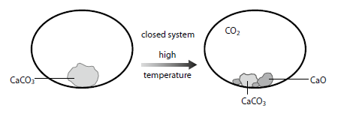
In a closed system, a state of equilibrium is attained.
Rate (forward) = Rate (reverse)
This type of equilibrium is called a dynamic equilibrium. All equilibria in chemistry are dynamic.
In dynamic equilibrium, macroscopic properties are constant (concentrations of all reactants and products remains constant) and the rate of the forward reaction is equal to the rate of the reverse reaction.

Equilibrium and rate of reaction

Consider the reaction H₂(g) + I₂(g) 2HI(g). If we start with just hydrogen and iodine vapour in a closed container at a certain temperature and follow how the concentration of hydrogen and hydrogen iodide change with time, we obtain a graph of the form shown.

The concentration of H₂ decreases at first, until it levels off when equilibrium is reached. The concentration of HI is initially zero, but it increases until it flattens off and does not change any more after equilibrium has been reached.
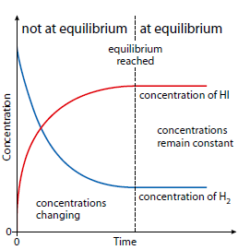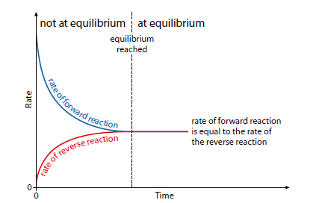
Graph showing how the rates of the forward and reverse reactions change as a reversible reaction comes to equilibrium.
Graph showing how the concentrations of hydrogen and hydrogen iodide change with time.

The characteristics of the equilibrium state
1 Macroscopic properties are constant at equilibrium – at equilibrium the concentrations of all reactants and products remain constant.
2 At equilibrium the rate of the forward reaction is equal to the rate of the reverse reaction.
3 Equilibrium can be attained only in a closed system – as we saw above, if calcium carbonate is heated in an open container, equilibrium is never reached because the carbon dioxide escapes and has no opportunity to recombine with the calcium oxide. In effect, a reaction going on in solution, but not involving the production of a gas, represents a closed system.
4 All species in the chemical equation are present in the equilibrium reaction mixture – for example, if nitrogen and hydrogen are allowed to come to equilibrium according to the equation N₂(g) + 3H₂(g) 2NH₃(g), the reaction mixture at equilibrium contains nitrogen, hydrogen and ammonia.
5 Equilibrium can be attained from either direction – consider the equilibrium:
CH₃COOH(l) + C₂H₅OH(l) CH₃COOCH₂CH₃(l) + H₂O(l)
ethanoic acid ethanol ethyl ethanoate water

A state of equilibrium, in which all four species are present, can be reached by mixing:
• ethanoic acid and ethanol
• ethyl ethanoate and water
• all four substances
• any three substances.
The actual concentrations present at equilibrium depend on how much of each substance we started with.
Physical equilibria
This is an equilibria involving a change in state, for example, the equilibrium between a liquid and its vapour.
Evaporation
When a liquid is in an open container it evaporates and the process is endothermic.The faster moving molecules (higher kinetic energy) are able to overcome the intermolecular forces, so they escape first and the average kinetic energy of the particles in the liquid phase drops.
Liquid–vapour equilibrium
Consider a volatile liquid, such as bromine, in a closed container. At the beginning there are no molecules of vapour above the liquid – molecules escape from the liquid (evaporation) but there is no condensation.
At first the rate of condensation is low, but as the number of molecules in the vapour phase increases the rate of condensation increases.
Eventually, when the rate of evaporation (vaporisation) is equal to the rate of condensation, the colour of the vapour remains constant and a state of equilibrium has been reached. This is known as a phase equilibrium.
Equilibrium is attained when the rate of evaporation is equal to the rate of condensation.
7.1.2 Position of equilibrium
Learning objectives
- Understand what is meant by the position of equilibrium
- Apply Le Chatelier’s principle to predict the effect of changes in conditions on the position of equilibrium

The ‘position of equilibrium’ refers to the relative amounts of reactants and products present at equilibrium. Some reactions go almost to completion, for example:
2NO(g) N₂(g) + O₂(g)
At 700 K, the position of equilibrium lies a long way to the right. There is a large amount of N2 and O2 and not very much NO at equilibrium. Equilibrium does not imply 50% reactants and 50% products.

Water dissociates according to the equation:
H₂O(l) H⁺(aq) + OH⁻(aq)
At 298 K the number of water molecules present at equilibrium is over 250 million times greater than the total number of H⁺ and OH⁻ ions. The position of this equilibrium lies a long way to the left.
The effect of changing conditions on the position of equilibrium – Le Chatelier’s principle
Le Chatelier’s principle
If a system at equilibrium is subjected to a change, the position of equilibrium will shift in order to minimise the effect of the change.
The effect of temperature
Consider the equilibrium:
2HI(g) H₂(g) + I₂(g) ΔH = +10 kJ mol⁻¹
At room temperature (298 K), the number of molecules of HI is 96.6% the total.
However, when the system reaches equilibrium at 700 K, the number of HI molecules is about 88%.
This means that there are relatively more H₂ and I₂ molecules present at equilibrium at 700 K than at 298 K. In this case, as the temperature increases, the position of equilibrium shifts to the right (there is more H₂ and I₂ present).
The value of ΔH given above refers to the forward direction – so in this case the forward reaction is endothermic and the reverse reaction is exothermic.
As the temperature is increased, the position of equilibrium shifts in the direction that will minimise the effect of the change in the endothermic direction.
HEAT reaction mixture: position of equilibrium is shifted in the endothermic direction.
COOL reaction mixture: position of equilibrium is shifted in the exothermic direction.

Consider the reaction:
N₂(g) + 3H₂(g) 2NH₃(g) ΔH = −92 kJ mol⁻¹
How does increase in temperature affect the position of equilibrium?

The effect of pressure
Consider this equilibrium:
2NO₂(g) N₂O₄(g)
brown colourless

Some NO₂ (brown) is put into a sealed gas syringe. As the pressure is increased, the colour initially gets slightly darker because the same number of molecules are squeezed into a smaller space.
At higher pressure there is less NO₂ (brown) and more N₂O₄ (colourless) present in the equilibrium mixture, and therefore it is a paler brown than at lower pressure.
As the pressure increases, the position of equilibrium shifts to the right.
Two moles of gas take up more space than one mole of gas, so as the pressure is increased the position of equilibrium shifts to the right in order to minimise the effect of this pressure change.
This reaction involves a decrease in the number of gaseous molecules, from two on the left-hand side to one on the right-hand side.
Two moles of gas take up more space than one mole of gas, so as the pressure is increased the position of equilibrium shifts in order to minimise the effect of this pressure change.

If a reaction involves a change in the number of gas molecules, an increase in pressure results in the position of equilibrium shifting in the direction that gives a decrease in the number of gas molecules.

Consider the following reactions:
- 2SO₃(g) 2SO₂(g) + O₂(g)
- 2HI(g) H₂(g) + I₂(g)
- CaCO₃(s) CaO(s) + CO₂(g)

What is the effect of increasing pressure to the position of equilibrium in each reaction?

The effect of concentration
Consider this system at equilibrium:
2[CrO₄]²⁻(aq) + 2H⁺(aq) [Cr₂O₇]²⁻(aq) + H₂O(l)
chromate(VI) ion from acid dichromate(VI) ion
yellow orange
The fact that the colour of the solution on the left is yellow indicates that the position of equilibrium lies to left, so there is significantly more of the yellow ion present than the orange ion.
When some acid (H⁺) is added to the mixture in the flask, the colour of the solution changes to orange. There is now much more of the orange dichromate(VI) ion present, which means that the position of equilibrium has shifted to the right.
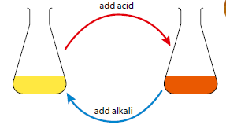
The chromate(VI) / dichromate(VI) equilibrium.

As more acid is added, the position of equilibrium shifts to the right to use up the excess acid and so minimise the effect of the change. The colour changes to orange.
If we now add an alkali (OH⁻) to the solution, the colour changes back to yellow. The OH⁻ ions react with the H+ ions to form water.
In general, if the concentration of one of the species in an equilibrium mixture is increased, the position of equilibrium shifts to the opposite side to reduce the concentration of this species.

7.1.3 Equilibrium constants
Learning objectives
• Write the expression for the equilibrium constant for a given reversible reaction
• Understand what is meant by reaction quotient
• Understand the connection between the size of the equilibrium constant and the extent of reaction
• Understand that it is possible to write more than one equilibrium constant for a particular reaction
• Understand how changing conditions affect the value of the equilibrium constant and the position of equilibrium

Various known amounts of ethanol and ethanoic acid are reacted together and allowed to come to equilibrium at the same temperature.

A series of experiments is carried out on the reaction:
CH₃COOH(l) + C₂H₅OH(l) CH₃COOCH₂CH₃(l) + H₂O(l)
ethanoic acid ethanol ethyl ethanoate water
The equilibrium concentrations of each component of the reaction mixture are determined and it is found that the ratio:
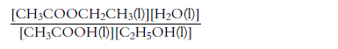
is constant for all the experiments.
If the same procedure is repeated for the reaction:
N₂(g) + 3H₂(g) 2NH₃(g) it is found that the following ratio is constant at a particular temperature:
This leads us to the general equilibrium law. For the reaction aA + bB c C + d D (where all reactants are in the same phase), the value of the following ratio is constant at a particular temperature:
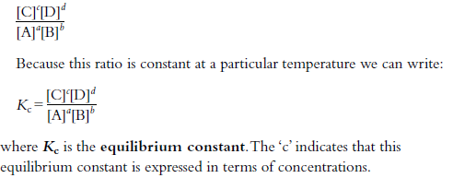
Kc is constant for a particular reaction at a particular temperature.

Write the equilibrium constant expression for the following reactions

N₂O₄(g) 2NO₂(g)

N₂O₅(g) + NO(g) 3NO₂(g)

CO(g) + 3H₂(g) CH₄(g) + H₂O(g)

What use is an equilibrium constant?
An equilibrium constant provides information about how far a reaction proceeds at a particular temperature.
Kc >> 1 – the reaction proceeds almost totally towards the products.
Kc << 1 – the reaction hardly proceeds at all towards the products.
The reaction quotient
The reaction quotient, Q, is the ratio of the concentrations of the reactants and products (raised to the appropriate powers) at any point in time. An expression for Q is exactly the same as that for the equilibrium constant – except that the concentrations are not equilibrium concentrations.
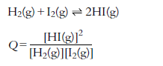
When the system is at equilibrium, the concentrations are all equilibrium concentrations and the value of Q is equal to the value of Kc at that temperature.
A system is still not at equilibrium if Q is not equal to Kc.
In general:
• If Q < Kc then the reaction must proceed towards the products (to the right) to reach equilibrium.
• If Q > Kc then the reaction must proceed towards the reactants (to the left) to reach equilibrium.
Two different values of the equilibrium constant for the same reaction under the same conditions.
There can be different values of Kc for the same reaction under the same conditions.
Consider the equilibrium 2NO₂(g) N₂O₄(g).
The expression for its equilibrium constant is:
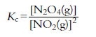 and the equilibrium constant is 0.69 at 400 K.
However, the reaction could also have been written the other way round:
N₂O₄(g) 2NO₂(g)
The expression for the equilibrium constant in this case is:
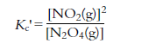
The value of the equilibrium constant at 400 K for this reaction is $\frac{1}{0.69}$ or 1.45.
Therefore these constants are only useful when quoted in conjunction with their equilibrium reactions.
Solve
Consider the equilibrium:
H₂(g) + I₂(g) 2HI(g). This can also be written as:

$\frac{1}{2}$H₂(g) + $\frac{1}{2}$I₂(g) HI(g)
What are the equilibrium constant expression for these two reactions and what is their relationship?

How changing the conditions affects the value of the equilibrium constant
The value of the equilibrium constant for a particular reaction is only affected by a change in temperature.

The effect of temperature
Exothermic reactions
CO(g) + 2H₂(g) CH₃OH(g) ΔH = −90 kJ mol⁻¹
The equilibrium constant expression for this reaction is:
Explain the effect of temperature rise on this reaction

Endothermic reactions
N₂(g) + O₂(g) 2NO(g) ΔH = +181 kJ mol⁻¹

Explain the effect of temperature rise on this reaction

Catalysts and the equilibrium constant
A catalyst increases the rate of forward and reverse reactions equally.
The presence of a catalyst does not affect the position of equilibrium or the value of the equilibrium constant; it only reduces the time taken to reach equilibrium.

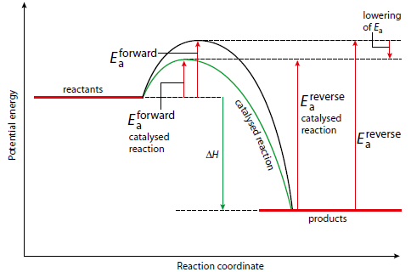
A potential energy profile for a reversible reaction A potential energy profile for catalysed and uncatalysed reactions

The equilibrium constant and rate
The equilibrium constant gives us information about how far a reaction goes towards completion (that is, about the extent of the reaction). It gives us absolutely no information about how quickly the reaction occurs. Kinetic data, such as the rate constant, indicate how quickly equilibrium is attained but provide no information whatsoever about the position of equilibrium and how far the reaction proceeds.

