2.2 Electron configuration
Learning objectives
- Describe the electromagnetic spectrum
- Describe the emission spectrum of hydrogen
- Explain how emission spectra arise
Understandings:
● Emission spectra are produced when photons are emitted from atoms as excited electrons return to a lower energy level.
● The line emission spectrum of hydrogen provides evidence for the existence of electrons in discrete energy levels, which converge at higher energies.
The main energy level or shell is given an integer number, n, and can hold a maximum number of electrons, 2n².
● A more detailed model of the atom describes the division of the main energy level into s, p, d, and f sub-levels of successively higher energies.
● Sub-levels contain a fixed number of orbitals, regions of space where there is a high probability of finding an electron.
● Each orbital has a defined energy state for a given electronic configuration and chemical environment and can hold two electrons of opposite spin.

The arrangement of electrons in atoms
At the simplest level of explanation, the electrons in an atom are arranged in energy levels (shells) around the nucleus. For example, the electron arrangement of potassium can be represented as shown in Figure 2.6 and is written as 2,8,8,1 (or 2.8.8.1).
The main energy level number is sometimes called the principal quantum number and is given the symbol n. The maximum number of electrons in each shell is given by 2n².

The electromagnetic spectrum: The visible spectrum gives us only a small window to see the world.

Light is a form of energy. Visible light is just one part of the electromagnetic

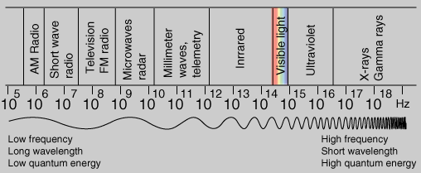
Electromagnetic spectrum
Although electromagnetic radiation is usually described as a wave, it can also display the properties of a particle, and we sometimes talk about particles of electromagnetic radiation called photons. White light is visible light made up of all the colours of the spectrum. In order of increasing energy, the colours of the spectrum are: red < orange < yellow < green < blue < indigo < violet.
All electromagnetic waves travel at the same speed, c = 3.00 × 10⁸ m s^{–1}. This is the cosmic speed limit as, according to Einstein’s Theory of Relativity, nothing in the universe can travel faster than this.
The distance between two successive crests (or troughs) is called the wavelength (λ). The frequency (V) of the wave is the number of waves which pass a point in one second. The wavelength and frequency are related by the equation c = Vλ, where c is the speed of light.
c = Vλ
A continuous spectrum is produced when white light is passed through a prism. The different colours merge smoothly into one another.

Atomic absorption and emission line spectra
When electromagnetic radiation is passed through a collection of atoms some of the radiation is absorbed and used to excite the atoms from a lower energy level to a higher energy level. The spectrometer analyses the transmitted radiation relative to the incident radiation and an absorption spectrum is produced.

Absorption and emission speatrum
The origin of absorption and emission spectra. An absorption spectrum shows the radiation absorbed as atoms move from a lower to a higher energy level. An emission spectrum is produced when an atom moves from a higher to a lower level.

The energy of a photon of electromagnetic radiation is directly proportional to its frequency and inversely proportional to its wavelength. It can be calculated from the Planck equation (E = hv).

Distinguish between a line spectrum and continuous spectrum .
Line spectrum – only certain frequencies/wavelengths of light present.
Continuous spectrum – all frequencies/wavelengths of light present

Evidence for energy levels in atoms
The hydrogen atom spectrum
Activity 1: use the spectrometer and the discharge tubes provided to observe the emission spectrum for various substance
Draw the set up showing how spectrometer is used to observe the hydrogen spectrum (steve owen p- 63) and also the emission spectrum for hydrogen.
Hydrogen at low pressure

Observing the emission of hydrogen spectrum
When hydrogen gas at low pressure is subjected to a very high voltage, the gas glows pink The glowing gas can be looked at through a spectroscope. Line spectrum is observed.
What are the observations?
- The lines get closer together at higher frequency/energy.
- Each element has its own unique emission spectrum, and this can be used to identify the element.
Atomic emission spectrum of hydrogen
Describe how the emission spectrum is formed
Passing an electric discharge through a gas causes an electron to be promoted to a higher energy level. The electron is unstable in this higher level and will fall to a lower energy level.
As it returns from a level at energy E2 to E1, the extra energy (E2 − E1) is given out in the form of a photon of light. This contributes to a line in the spectrum.

Evidence of energy levels
The fact that a line spectrum is produced provides evidence for electrons being in energy levels (shells): i.e. electrons in an atom are allowed to have only certain amounts of energy

Convergence and convergence limit
∞
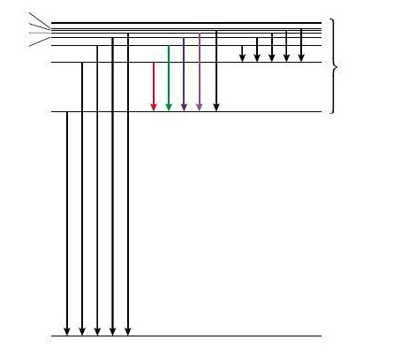
8
7
00
6

5
4
3
Paschen series
excited states
2
Balmer series
UV
Lyman series
1
ground state
Energy levels of the hydrogen atom showing the transitions which produce the Lyman, Balmer, and Paschen series. The transition 1 to ∞ corresponds to ionization.

The lines in the emission spectrum get closer together at higher frequency/energy.
Eventually, at the convergence limit, the lines merge to form a continuum. Beyond this point the electron can have any energy and so the electron is no longer in the atom. The atom has been ionized. The first ionization energy of an element is the minimum energy needed to remove one mole of electrons from one mole of gaseous atoms in their ground state.

