**Excel simulation – Air resistant fall**

**Purpose and motivation**

The purpose of this activity is to simulate the evolution of the velocity of an object falling in a context in which the air resistance cannot be ignored. The motivation for using an iterative process within excel is because there is a loop dependency within the variables.

An object falling from rest will be accelerated by the gravitational force. At first, it won’t have much air resistance since this depends on the speed. However, while it accelerates, its speed will keep increasing which will make the air resistance, the force opposing the weight, larger and larger. This will cause a decreasing accelerating force making the rate at which the velocity increases slower. Eventually the object will reach an equilibrium state in which the weight and the drag force balance each other, thus having no net acceleration and therefore reaching constant **terminal velocity**.

**Setting up variables describing the system**

These number describe the condition of the system and are all needed to create the simulation

* 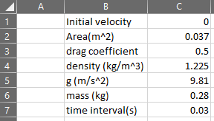Area is the cross sectional area of the falling object.
* The drag coefficient is related to the geometry of the object.
* Density refers to the density of the fluid. The value present is the density of air in standard conditions.
* g is the gravitational field strength
* mass is the mass of the falling object

**The iterative calculation**

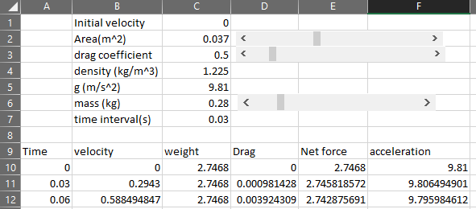

**Time column**

Cell A10: “=0”

The next cell in time will be the previous time + the time interval we defined for our simulation in C7.

Cell A11: “=A10+$C$7”

The $ sign is to signal that the column/row should not be changed when the equation is expanded to other cells.

**Velocity column**

Cell B10: “=C1”

The next cell will be the velocity after the defined time interval (0.03s) which will change if there is a net force acting on the object

V=u+at

Cell B11=B10+F10*$C$7

**Weight column**

W=mg

Cell C11: “=$C$6*$C$5”

**Drag column**

The drag force will be dependent on the velocity

Cell D10: “=0.5*$C$4*$C$3*$C$2*B10^2”

**Net Force**

The net force downwards will be the weight-drag force which opposes the motion

Cell E10: “=C10-D10”

**Acceleration**

To close the iterative loop and finally give the value that will be used to update the new velocity in B10 we need the value of acceleration in F10

Cell F10: “=E10/$C$6”

To finish, expand the last row of each column downwards for as many rows as you want. This would mean more simulation time.

Plot a graph of Speed vs Time to see the evolution.

**Extension 1** [Save the file with a different name]

Modify the excel in such a way that the drag is described by the Stokes’ law drag equation



This is usually the case for spherical object at small velocities. What is the change in the shape of the graph?

**Extension 2** [Save the file with a different name]

Modify the excel by reducing the number of intermediary columns. Just have time, velocity and acceleration columns. Your formula for acceleration should contain all the required calculations.

**Extension 3 – Especially challenging** [Save the file with a different name]

Modify the excel to produce a position time graph instead of a velocity time graph.