- Basic Concept and formula
  - Express power in term of energy and change in time
  - Expression in term of force and velocity

$P=\frac{∆E}{∆T}=\frac{∆W}{∆T}=\frac{Fd}{∆T}=Fv$

- A 50-kg person runs up the stairs 10 meters high in 2 minutes. Acceleration due to gravity (g) is 10$\frac{m}{s^{2}}$. Determine the power.

W = m g h = (50)(10)(10) = 5000 Joule.
P = W / t = 5000 / 120 = 41.7 Joule/second.

- You’re riding a toboggan down an icy run to a frozen lake, and you accelerate the 80.0-kg combination of you and the toboggan from 1.0 m/s to 2.0 m/s in 2.0 s. How much power does that require?

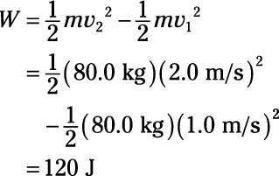
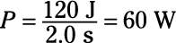

- A 1,000-kg car accelerates from 88 m/s to 100 m/s in 30 s. How much power does that require?

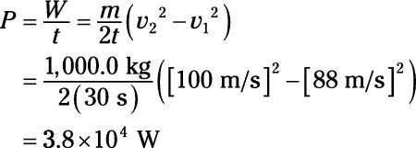
- A 60.0-kg person is running and accelerates from 5.0 m/s to 7.0 m/s in 2.0 s. How much power does that require?
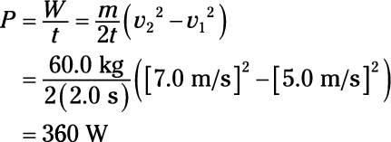

- A 120-kg linebacker accelerates from 5.0 m/s to 10.0 m/s in 1.0 s. How much power does that require?
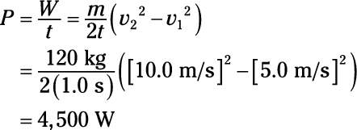

- 4.You’re driving a snowmobile that accelerates from 10 m/s to 20 m/s over a time interval of 10.0 s. If you and the snowmobile together have a mass of 500 kg, how much power is used?
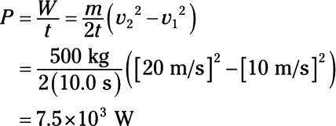

- Sources for problems: https://scienceknowledge.webador.com/physics-content/ib-physics/mechanics/work-energy-and-power/power
- Provided by: https://scienceknowledge.webador.com/

