- Two point charges, QA = +8 μC and QB = -5 μC, are separated by a distance r = 10 cm. What is the magnitude of the electric force. The constant k = 8.988 x 10⁹ Nm²C⁻² = 9 x 10⁹ Nm²C⁻².

- Two small plastic balls are separated by 20 cm. Their charge, mass, and radii are also given. If both balls are free to move,
- Which ball experiences a larger force? Explain.
- When the balls collide, which will be moving faster? Explain.
- Find the force (mag. and dir.) on each ball.
- Find the acceleration (mag. and dir.) of each ball.

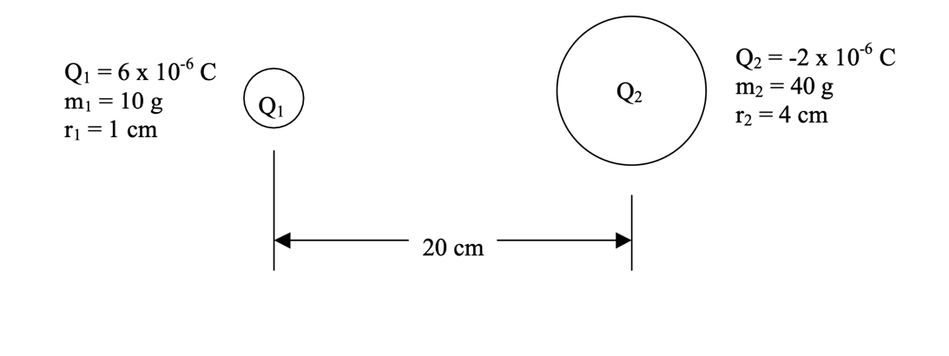

3. Two charges QA = QB = +Q are held fixed on the y-axis at (0, 3d) and (0,-3d). A third charge, QC = +Q, is released from rest on the x-axis at (4d, 0).
- Which way will QC move? Explain.
- Describe the motion of QC. Does it speed up? Slow down? Turn around? Where is it fastest? Etc.
- Find the force (mag. and dir.) on QC.
- Repeat a) – c) for the case where QC = -2Q.

