6.2.3 Reaction mechanism

Learning objectives
- Understand what is meant by the mechanism of a reaction and the rate-determining step
- Work out reaction mechanisms from experimental data and relate a given mechanism to the experimental data
Introduction
Most reactions that occur at a measurable rate occur as a series of simple steps, each involving a small number of particles (collision theory).
This sequence of steps is known as the reaction mechanism. The individual steps, called elementary steps, usually cannot be observed directly, so the mechanism is in effect a theory about the sequence of events.
It is worth noting though, that while kinetic evidence can help to support a particular mechanism, it cannot prove it to be correct – only that it is consistent with the observed data.

The order of a chemical equation cannot be derived directly from a chemical equation.

If in the reaction; 2NO₂(g) + F₂(g) → 2NO₂F(g) were all to occur in one single step, all three molecules must collide together at exactly the same time.

The rate of reaction in this case would therefore depend on [NO2]2 and [F2], and the rate equation would be:
rate = k[NO₂]²[F₂]
The actual rate equation obtained from experiment is, however,
rate = k[NO₂][F₂]
So the reaction does not occur in just one step in which all three molecules collide and break apart to form the products. The chance of three gas molecules all colliding at exactly the same time is extremely small.
It is most likely that each step involves just two molecules colliding.
A reaction mechanism consists of a series of steps that make up a more complex reaction. Each simple step involves a maximum of two molecules colliding.

The proposed mechanism for this reaction is:

NO₂ + F₂ → NO₂F + F step 1
NO₂ + F → NO₂F step 2

The mechanism must agree with the overall chemical equation. This can be checked by adding the two equations (steps) together and cancelling the species that are on both sides.

NO₂ + F₂ → NO₂F + F step 1
NO2 + F → NO2F step 2
2NO₂ + F₂ → 2NO₂F overall equation
F is an intermediate and is used up in step 2
Rate expression for each stage:

Step 1: rate = k₁[NO₂][F₂]
Step 2: rate = k₂[NO₂][F]

The rate equation for step 1 is the same as the experimental rate equation, and so it would seem that this step governs the overall rate of reaction.
The second step has no apparent effect on the rate. Step 1 is called the rate-determining step of the mechanism and occurs significantly more slowly than step 2.
slow
NO₂ + F₂ → NO2F + F step 1 rate-determining step

fast
NO₂ + F → NO₂F step 2

This means that changing the concentrations of the species present in the fast second step does not affect the rate of the reaction to any great extent.
The slowest step in a reaction mechanism is called the rate-determining step.

The potential energy profile for this reaction shows that the rate-determining step (step 1) has a much higher activation energy than the other step.
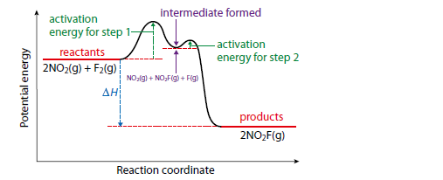
Potential energy profile for a two-step reaction. The formation of an intermediate is shown by the potential energy well in the profile.

The term molecularity is used in reference to an elementary step to indicate the number of reactant species involved. So unimolecular refers to an elementary step that involves a single reactant particle, bimolecular refers to an elementary step with two reactant particles. In the reactions above both steps are bimolecular. Termolecular reactions (those that involve three reactant particles) are rare (collision theory supports).
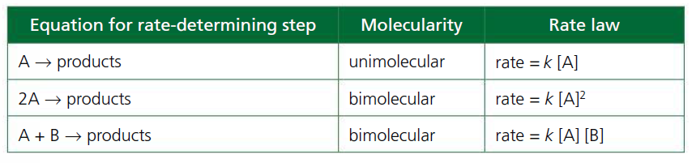
Example 1
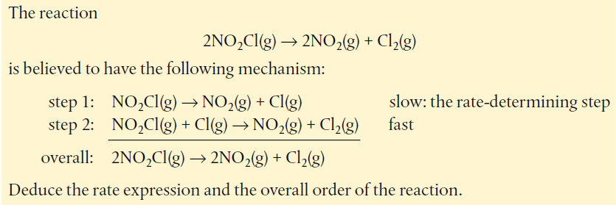

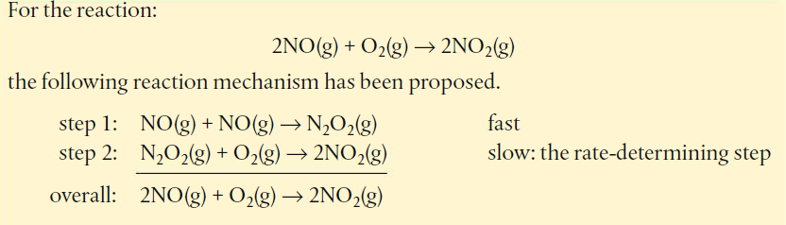
- What is the rate expression and the overall order for the reaction?
- From the examples, what does it mean for a reaction to be zero order with respect to a particular reactant?

TOK
Reaction mechanisms can be supported by indirect evidence but cannot be observed. What evidence would be needed to accept a proposed reaction mechanism as certain?

Reactions involving a catalyst
Consider;
CH₃COCH₃(aq) + I₂(aq) → CH₃COCH₂I(aq) + HI(aq)
This reaction is acid (H⁺) catalysed. The experimental rate equation is:
rate = k[CH₃COCH₃][H⁺]

The rate equation does not include I2, so this must be involved only after the rate-determining step.
The mechanism could be proposed as:
CH₃COCH₃ + H⁺ → X rate-determining step (X is an intermediate).
X + I₂ → CH₃COCH₂I + HI + H⁺ fast

H⁺ will cancel out when the equations are added together.
The catalyst is involved in the rate-determining step but is regenerated in the second step and therefore does not appear in the overall chemical equation.
Catalysts change a reaction mechanism, allowing the reaction to occur via an alternative pathway that has a lower activation energy.

Nature of science
The principle of Occam’s (Ockham’s) razor is often used in science to decide between different theories.It involves the idea that if there are two theories that give equally acceptable explanations of experimental data, the simpler one should be adopted.
This is often used to decide between different reaction mechanisms.
We should seek the simplest possible mechanism that is consistent with the rate equation and the stoichiometric equation.

6.3 Activation energy: The rate constant k is temperature dependent.

The Arrhenius equation
Learning objectives
- Understand that increasing the temperature causes the rate constant to increase
- Work out values of activation energy and the frequency factor (pre-exponential factor) using the Arrhenius equation

In a rate equation such as rate = k[A][B],as the temperature increases, the rate constant increases exponentially.
The temperature dependence of the rate constant is expressed in the Arrhenius equation.
Svante Arrhenius showed that the fraction of molecules with energy greater than activation energy, Ea, at temperature T is proportional to the expression:
$${e^{-}}^{\frac{Ea}{RT}}$$where R is the gas constant (= 8.31 J K–1 mol–1) and T is the absolute temperature (in K). This must mean that the reaction rate, and therefore also the rate constant, are also proportional to this value.
So we can write;

k$α {e^{-}}^{\frac{Ea}{RT}}$ and k$=A {e^{-}}^{\frac{Ea}{RT}}$
where;

- A is called the frequency factor (also called the pre-exponential factor, A-factor or Arrhenius constant) and takes account of the frequency of collisions and the orientation of the collisions.

- ${e^{-}}^{\frac{Ea}{RT}}$represents the fraction of collisions that have E ≥ Ea. However, not all collisions with E ≥ Ea result in reaction and A contains a factor that allows for this to be considered.

Using the Arrhenius equation to calculate activation energy
If we take the natural logarithm (logarithm to base e) of both sides of the equation above, we find that

Ink = - $\frac{Ea}{RT}$ × + InA

This is a form of the equation for a straight line y = mx + c. So a graph of ln_k (y-axis) against 1/T (x-axis) will give a straight line with gradient (m) = –Ea/R. This is known as an Arrhenius plot.
R is the gas constant ( 8.31JK⁻¹mol⁻¹) and so

Gradient =- $\frac{Ea}{R}$ and – Ea = gradient x R
Intercept on the graph on the y-axis (ln K axis is lnA and the value of A can be calculated. See examples on the textbook.

