**4.2 Covalent bonding**

**Learning objectives**

* Understand that a covalent bond is formed when electrons are shared
* Understand the relationship between bond strength and bond length
* Understand what is meant by electronegativity
* Predict whether a bond will be polar or not

|  |
| --- |
| **Covalent bonding occurs when atoms share electrons, and a covalent bond is the electrostatic attraction between a shared pair of electrons and the nuclei of the atoms that are bonded.** |

**Single covalent bonds**

At the simplest level, electrons are shared to allow the atoms being bonded to achieve a full outer shell of electron.

Examples

1. Methane CH4



Methane molecule



H

H C H

H

H

H C H

H

These are two alternative ways of representing the covalent bonding in methane. They are called the Lewis structures.

Draw the Lewis structure for the following molecules and describe if they have lone pair of electrons.

1. Water
2. Ammonia
3. Oxygen
4. Nitrogen
5. Carbon dioxide
6. Carbon monoxide
7. Ethene C2H4

**What holds the atoms together in a covalent bond?**

|  |
| --- |
| **A covalent bond is the electrostatic interaction between the positively charged nuclei of both atoms and the shared pair of electrons.** |

The electrons are negatively charged and because the shared electrons are attracted to the nuclei (positively charged) of both atoms simultaneously, this holds the atoms together.

This is because the attraction of the two nuclei for three electron pairs (six electrons) in a triple bond is greater than the attraction for two electron pairs (four electrons) in a double bond.

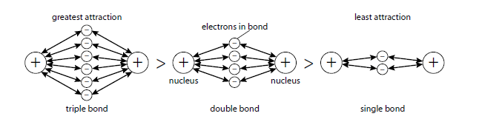



The relationship between number of bonds and bond length/strength.

In general, when we are comparing just single bonds, the longer the bond the weaker it is.



**Polarity**

**Electronegativity**

In a covalent bond between two different atoms, the atoms do not attract the electron pair in the bond equally. How strongly the electrons are attracted depends on the size of the individual atoms and their nuclear charge.

**Electronegativity is a measure of the attraction of an atom in a molecule for the electron pair in the covalent bond of which it is a part.**

In F2 the electrons are shared equally and the molecule is non-polar.

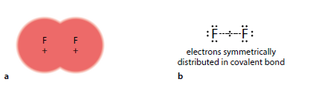

In HF, fluorine is more electronegative than hydrogen and attracts the electrons in the H–F bond more strongly than the hydrogen atom does. The electrons in the bond lie closer to the fluorine than to the hydrogen (Figure **below**). H–F is a polar molecule. The unsymmetrical distribution of electron density results in small charges on the atoms. Fluorine is δ− because the electrons in the bond lie closer to F, whereas electron density has been pulled away from hydrogen, so it is δ+.



**Atoms with similar electronegativities will form covalent bonds. Atoms with widely different electronegativities will form ionic bonds. The difference in electronegativity can be taken as a guide to how ionic or how covalent the bond between two atoms is likely to be.**

Linus Pauling related the electronegativity difference between two atoms to the ionic character of a bond. He suggested that an electronegativity difference of 1.7 corresponded to 50% ionic character in a bond and reasoned that a higher electronegativity difference than this corresponded to a structure that was more ionic than covalent, whereas if the difference is less than 1.7, the bonding is more covalent than ionic. This is a useful idea, but it must be used with great caution.