- An object starts to be in freefall motion from a certain height from the ground. If the total time for the first half of the journey is t, what is the time it takes the object to fall the whole way?
- An object is dropped from the top of a building, and hits the ground with a speed of v。How much time does it take for the object to fall from the top of the building to the upper half of the building?

- The object is in free fall from a height H above the ground. How far does the object fall when its velocity is equal to half the velocity of its impact?

- When an object is in free fall, it hits the ground at twice the speed of passing point P in the air. Given that point P is 15m above the ground, and g = 10 m/s^2. Find :(1) the velocity of the object when it hits the ground; (2) The time that the object moves in the air.

- An object falls from the top of a building and passes a window with a heigh of 1.8 m in 0.2 seconds. Calculate the distance between the window and the building

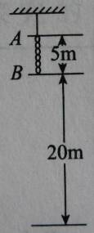
- A chain of 5m is hanged by a thin wire in stationary. After the wire is cut, find the time taken for the chain to pass through 20m directly below its lower end point

- Water droplets fall from the roof of a building after a constant time interval. At the time when the fifth droplet starts to fall, the first droplet reaches the floor; the third and the second droplets are at the upper and lower parts of a window of 1m respectively.
  - Calculate the distance between the roof and the floor
  - Find the time interval between each droplet, given that g=10 m/s²

Window

