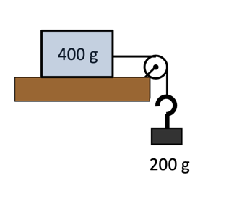
- A 400-gram package lying on a horizontal surface is attached to a horizontal string which passes over a smooth pulley. When a mass of 200 grams is attached to the other end of the string, the package is on the point of moving. Find μ, the coefficient of friction.

- Take g = 9.8 ms–2 1a A parcel of mass 2 kg lies at rest on a rough horizontal surface, as shown.
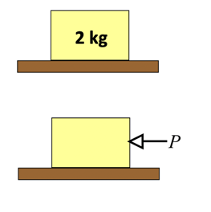
  - Draw a force diagram showing the forces acting on the parcel.
  - Calculate the normal contact force, R. b
  - The parcel is now pushed with a horizontal force P, as shown, so that it is just on the point of sliding.
    - Draw a force diagram showing the forces now acting on the parcel.
    - If the coefficient of friction is 0.5, find the value of P when the parcel is on the point of sliding.

- 2 A dustbin of mass 12 kg standing on horizontal ground is pushed by a horizontal force of 40 N. If the coefficient of friction is 0.4, will the dustbin move?

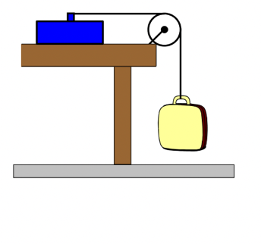
- One end of a light inextensible string is attached to a tool box of mass 2.5 kg which is lying on a horizontal table. The string passes over a smooth pulley and is tied at the other end to a bag of mass 1.4 kg.
  - Draw a diagram showing the forces acting on the tool box.
  - If the tool box is just on the point of sliding, find a value for μ, the coefficient of friction.

- A car of mass 1.2 tonnes is travelling along a straight horizontal road at a speed of 20 ms–1 when it brakes sharply then skids. Friction brings the car to rest.
  - If the coefficient of friction between the tyres and road is 0.8, calculate the deceleration
  - The distance travelled by the car before it comes to rest.

- A car of mass 1 tonne is travelling along a straight horizontal road at 15 ms–1 when it brakes sharply then skids. Friction brings the car to rest. If the coefficient of friction between the tyres and road is 0.75, calculate:
  - the deceleration
  - the time taken for the car to come to rest.

- A cup of coffee of mass 250 grams sits on a table in a train carriage. The train accelerates at 1.2 ms–2 out of a station.
  - Draw the forces acting on the cup of coffee. If the cup does not slip, find the value of the friction force acting on the cup of coffee.
  - If the cup is just about to slip, find the coefficient of friction between the cup and the surface of the table.

- A woman is trying to push a load of mass 50 kg across a floor. The woman exerts a force of 70 N.
  - Modelling the floor as smooth and the load as a particle, calculate the acceleration of the load.
  - Assuming that a constant resistive force of 56 N is acting, calculate:
    - the acceleration of the load
    - the coefficient of friction, μ, between the load and the ground, assuming the resistive force is due only to friction.

- A trunk of mass 30 kg is standing on a horizontal floor.The coefficient of friction, μ, between the trunk and floor is 0.3.
  - Find the maximum value the friction can attain.
  - Find the force that is necessary:
    - to keep the trunk sliding over the floor with constant speed
    - to cause the trunk to slide over the floor with acceleration 0.2 ms–2.

