- Two identical balls A and B are shown separated by a distance d. Both balls have positive charge +Q, i.e. QA = QB = +Q. Both balls are free to move.
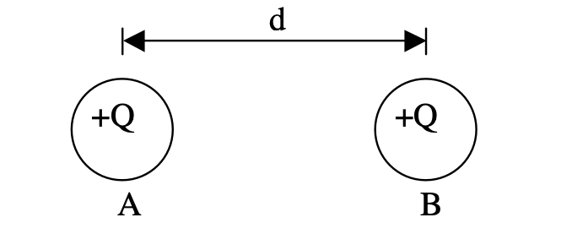
a) Q: Which ball experiences a larger force? Explain.
b) Q: Which ball experiences a larger acceleration? Explain.
c) Q: Describe the acceleration of A over time (direction, magnitude, etc).
d) Q: Describe the velocity of A over time (direction, magnitude, etc)
For original arrangement shown, now assume B is held fixed,
e) Q: Where can you place a third ball C, QC = +Q, so that A will remain stationary: to the left of A, between A and B, or to the right of B? Explain.
f) P: Calculate the location of ball C for part e).
g) Q&P: repeat e) – f) for ball C with QC = +Q/2
h) Q&P: repeat e) – f) for ball C with QC = -9Q.

- Two small plastic balls are separated by 20 cm. Their charge, mass, and radii are also given. If both balls are free to move,
- Q: Which ball experiences a larger force? Explain.
- Q: When the balls collide, which will be moving faster? Explain. c)
- P: Find the force (mag. and dir.) on each ball.
- P: Find the acceleration (mag. and dir.) of each ball.
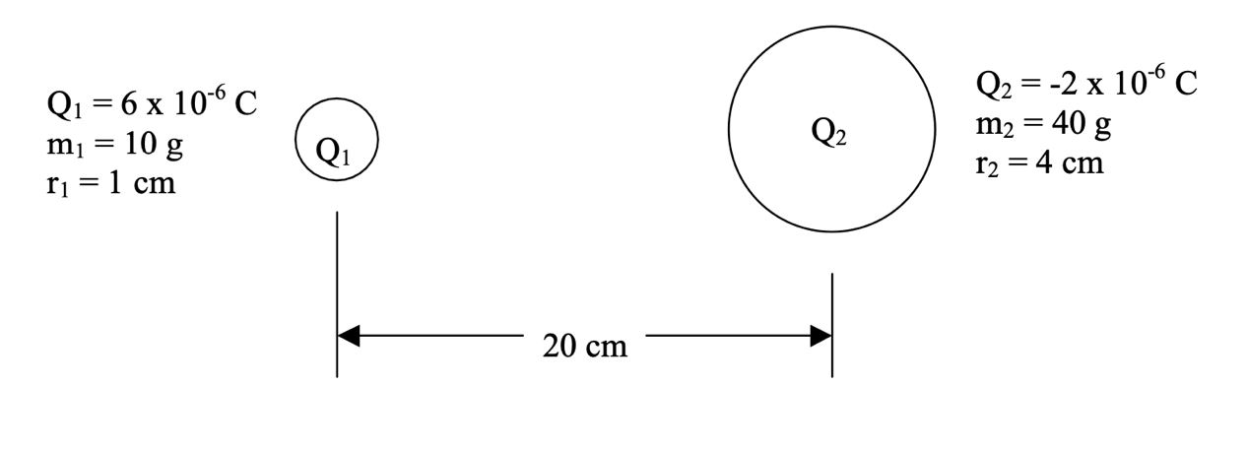
- Two charges QA = QB = +Q are held fixed on the y-axis at (0, 3d) and (0,-3d). A third charge, QC = +Q, is released from rest on the x-axis at (4d, 0).
  - Q: Which way will QC move? Explain.
  - Q: Describe the motion of QC. Does it speed up? Slow down? Turn around? Where is it fastest? Etc.
  - P: Find the force (mag. and dir.) on QC.
  - Q&P: Repeat a) – c) for the case where QC = -2Q.
4. If you rub a balloon on your shirt, the balloon becomes negatively charged. a) Q: Where do the negative charges come from?
- The friction created new negative charges on both the balloon and your shirt.
- The friction transferred electrons from your shirt to the balloon making the shirt positive and the balloon negative.
- The friction activated the electrons that were already on the balloon.

- If you rub a balloon on your shirt, the balloon becomes negatively charged.
  - Q: Where do the negative charges come from?
- The friction created new negative charges on both the balloon and your shirt.
- The friction transferred electrons from your shirt to the balloon making the shirt positive and the balloon negative.
- The friction activated the electrons that were already on the balloon.
- Usually we consider a charge as a single object. E.g. Figure 1 shows the balloon near a free particle.
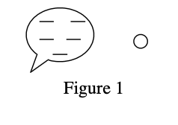
b) Q: What is the direction of the force on the balloon if the particle is
- A neutron?
- A proton?
- iii. An electron?
But macroscopic objects are not single charges. Rather they are made up of many electrons, protons, and neutrons. Sometimes we want to be more detailed in our approach. E.g. Figure 2 shows the balloon very near a neutral block
- c) Q: If the block is made of copper, sketch the behavior of the charges in the block and the force on the balloon?
- d) Q: If the block is made of wood, sketch the behavior of the charges in the block and the force on the balloon?
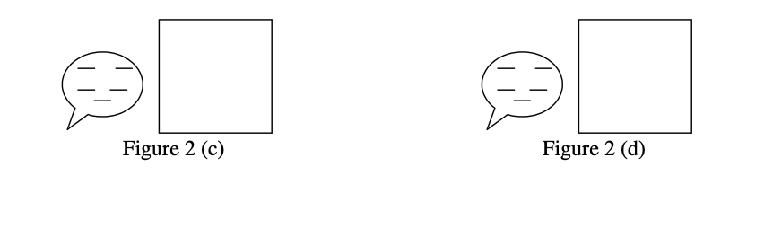

- A positively charged metal sphere X is a distance d away from an uncharged metal sphere Y of the same radius. The two spheres are then brought together until they touch, and then returned to a distance d apart.
Q: Which of the following statements do you agree with and why?
- a) Both X and Y are negatively charged.
- b) Both X and Y are positively charged.
- c) X is negative and Y is positive.
- d) X and Y attract each other.
- e) X and Y repel each other.
- f) X loses electrons to Y .
- g) Y loses electrons to X.

- Two small metal balls of equal size are positioned a distance d apart and have initial charges Q1 and Q2. In all the parts the balls are brought together, allowed to touch, and then returned to the original separation distance d.

a) Q: Suppose the balls initially repel one another. After they touch and are separated do they now repel, attract, or exert no force on one another? Explain.
NOW GO BACK TO INITIAL CONDITIONS!!!!
b) Q: Suppose the balls initially attract one another. After they touch and are
separated do they now repel, attract, or exert no force on one another? Explain.
NOW GO BACK TO INITIAL CONDITIONS AND DO THIS NUMERICAL EXAMPLE
GivenQ1=-2μC,Q2 =+4μCandforcehasmagnitudeF=32N
c) P: After they touch and are separated what is the new force between them? (mag. and dir.)
d) Q: Which way do actual charges flow? Explain.

7. Two balls hang from the ceiling separated by a distance d = 1.0 m. They hang by threads of length L = 0.2 m. The balls have mass m = 10 g. Initially the balls are uncharged and hang straight down.
- a) P: When both are rubbed with fur, they repel each other making an angle of θ = 30° with the vertical. Find the charge on each ball.
- b) Q: Next one ball is left as is, while the other is rubbed with saran wrap. You may assume the saran wrap creates the same magnitude charge as the fur did. They now attract one another, making an angle φ with the vertical. Is φ bigger, smaller or equal to θ (i.e. 30°)? Explain.
