**7.2 The equilibrium law (HL)**

**Learning objectives**

• Solve problems involving equilibrium constants

• Understand the relationship between the equilibrium constant and the Gibbs free energy

**Calculation of equilibrium constants**

Calculating a value for the equilibrium constant simply involves putting the concentration values into the equilibrium constant expression.

**Example 1**

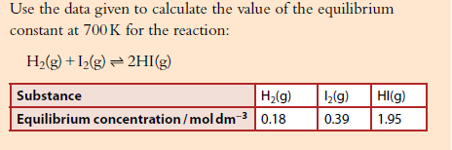****

**Problem1**



**Problem 2**



**Example 3**

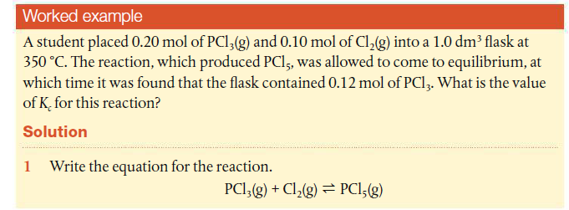



**Problem 3**

**Example 4**

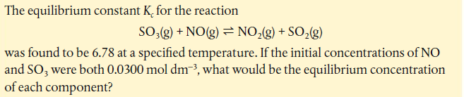

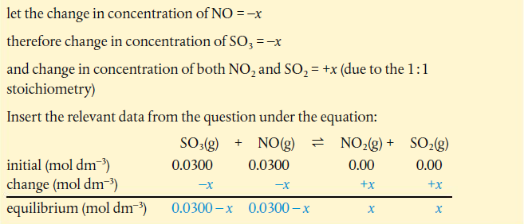



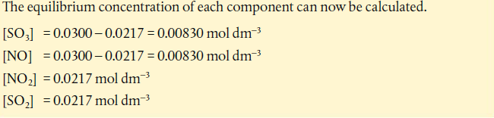

**Calculating equilibrium concentrations when *Kc* is very small**

In some reactions the value of *Kc* is very small, less than 10–3. The equilibrium mixture consists almost entirely of reactants.

[reactant]initial ≈ [reactant]equilibrium

Example

The thermal decomposition of water has a very small value of *Kc*. At 1000°C, *Kc* = 7.3× 10–18 for the reaction

2H2O(g)  2H2(g) + O2(g)

A reaction is set up at this temperature with an initial H2O concentration of 0.10 mol dm–3. Calculate the H2 concentration at equilibrium.

Let the concentration of H2 be x. From stoichiometric relationship, the concentration of O2 will be x.

So it will make the calculation easier if we proceed as follows: change in concentration of H2 = 2*x* change in concentration of O2 = *x* so change in concentration of H2O = –2*x*.

Let the concentration of H2 be x. From stoichiometric relationship, the concentration of O2 will be x.

So it will make the calculation easier if we proceed as follows: change in concentration of H2 = 2*x* change in concentration of O2 = *x* so change in concentration of H2O = –2*x*.

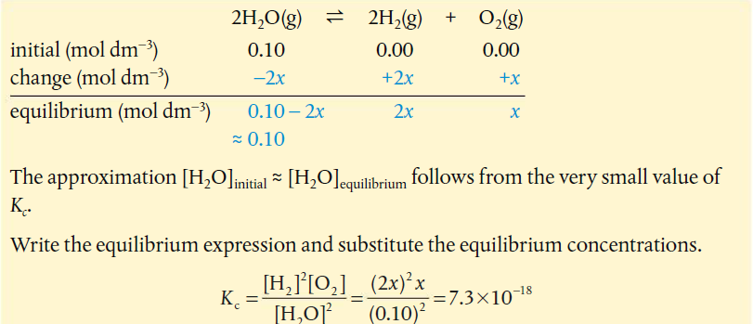

This can now be solved for *x*.

4*x*3 = (7.3 × 10–18)(0.010) = 7.3 × 10–20

*x* = 2.632 × 10–7

The equilibrium concentration of H2 can now be calculated.

[H2] equilibrium = 2*x* = 5.3 × 10–7 mol dm–3

**Free energy and equilibrium**

Remember that the Gibbs free energy change, Δ*G*, is a measure of the work that is available from a system. Its sign is used to predict the spontaneity of a reaction. Equilibrium occurs when a reaction mixture is at minimum value of Gibbs free energy.

Δ***G***\* = **negative** _ **reaction proceeds in the forward direction**

Δ***G***\* = **positive** _ **reaction proceeds in the backward direction**

ΔG *= **0** _ **reaction is at equilibrium**

The free energy change Δ *G*\* can be calculated for a reaction from the equation:

Δ*G*\* = *G*\*products – *G*\*reactants

so at equilibrium:

*G*\*products = *G*\*reactants

So Δ *G*\* can be used to predict the spontaneity of a reaction and the position of equilibrium as follows.

* A reaction with a value ofΔ *G*\* that is both large and negative, appears to occur spontaneously has an equilibrium mixture with a high proportion of products.
* A reaction with a value of Δ *G*\* that is large and positive, appears to be non-spontaneous as only minute amounts of product form. It has an equilibrium mixture that is predominantly reactants.

**Gibbs free energy and equilibrium**  (topic 5.5)

Consider the Haber process for the production of ammonia:

N2(g) + 3H2(g)  2NH3(g) Δ*G* = −33 kJ mol−1

According to the discussion above, this reaction will proceed from left to right – nitrogen and hydrogen will spontaneously become ammonia – but the reverse reaction (ΔG = +33 kJ mol−1) will not occur spontaneously.

The equilibrium mixture always has a lower Gibbs free energy (higher entropy) than either the pure reactants or the pure products (a mixture has higher entropy than pure substances) therefore the conversion of either reactants **or** products into the equilibrium mixture results in a process in which Δ*G* is negative.



The value and sign of Δ*G* give us information about the position of equilibrium. If Δ*G* is negative then the position of equilibrium will lie closer to the products than the reactants. The more negative the value of Δ*G*, the closer the position of equilibrium lies towards the products. If Δ*G* is numerically very large and negative then the position of equilibrium lies very close to pure products.



**a Δ*G* is negative and the position of equilibrium lies closer to the products; b Δ*G* is positive and the position of equilibrium lies closer to the reactants.**

***Kc* can be calculated from thermodynamic data**

These two constants relate to the position of equilibrium as described.

*Kc*, the equilibrium constant;

Δ *G*\*, the change in free energy.

The equation which shows this relationship is derived from the principles of thermodynamics.

Δ *G*\* = –*RT*ln*K*

This equation is given in section 1 of the IB data booklet

* Δ *G*\* = standard free energy change of the reaction
* *R* = the gas constant 8.31 J K–1 mol–1
* *T* = the absolute temperature, in Kelvin
* ln*K* = the natural logarithm of the equilibrium constant, *Kc*.

For a reaction in solution then the equilibrium constant obtained will be *K*c.

For reactions involving gases, the equilibrium constant obtained is *K*p, which is the equilibrium constant in terms of partial pressures.

Partial pressure refers to the pressure exerted by a particular gas in a mixture of gases.

The expression for *K*p is the same as that for *K*c except concentrations are replaced by partial pressures. For the reaction

N2(g) + 3H2(g)  2NH3(g)

the expression for *K*p is



where PN2 represents the partial pressure of nitrogen at equilibrium and so on.

**Relationship between Kp and Kc**

Concentration is number of moles per unit volume (n/V), therefore, from Pv =nRT,

P= $\frac{n}{v}$ RT

or, partial pressure of a gas = [concentration] × RT

It can then be worked out that *K*p = *K*c × (RT)Δn where Δn is the number of molecules of gas on the right hand side of an equation – the number of molecules of gas on the left hand side. For the reaction given above Δn = –2 and *K*p ≠ *K*c but for H2(g) + I2(g)  2HI(g) Δn = 0 and *K*p = *K*c.

From Δ *G*\* = –*RT*ln*K*, equation we can deduce relationships between Δ *G*\* and *Kc* for a reaction.



Example using Δ *G*\* = –*RT*ln*K*

The esterification reaction that produces ethyl ethanoate has a free energy change Δ *G*\* = –4.38 kJ mol–1.

CH3COOH(aq) + C2H5OH(aq)  CH3COOC2H5(aq) + H2O(aq)

Calculate the value of the equilibrium constant of this reaction at 298 K.

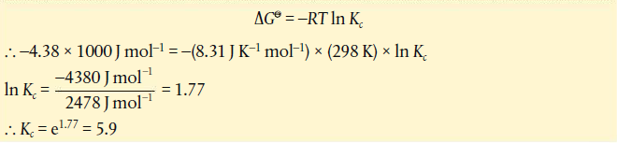

We have now answered the question about what determines the fact that different reactions have such different values of equilibrium constant. The answer is the value Δ *G*\*. Remember from Chapter 5 that this in turn depends on the values of enthalpy change (Δ *H*) and entropy change (Δ *S*) for the reaction.

**The position of equilibrium corresponds to a maximum value of entropy for the system.**  (ΔGθ = ΔHθ - TΔSθ)

**Kinetics and equilibrium**

Consider a reaction which we will assume occurs in a single step. In other words, the overall reaction is an elementary bimolecular reaction.

A + B  C + D

In this case (and only in this case), we can write the rate laws for the forward and backward reactions from the stoichiometry of the reaction.

rate of forward reaction = *k*[A][B]

rate of backward reaction = *k’* [C][D]

where *k* = rate constant for the forward reaction and *k*’= rate constant for the backward reaction.

The equilibrium constant expression for this reaction is:

*Kc* = $\frac{\left[C\right][D]}{\left[A\right][B]}$

At equilibrium, the rate of the forward reaction = rate of backward reaction, so

*k*[A][B] = *k’*[C][D] Rearranging $\frac{k}{k'}$ = $\frac{\left[C\right][D]}{\left[A\right][B]}$ or *Kc* = $\frac{k}{k'}$

In other words, the equilibrium constant is the ratio of the rate constants of the forward and backward reactions. This equation provides a fundamental link between chemical equilibrium and chemical kinetics.

