Diagrams of further aspects of covalent bonding
ClF₃
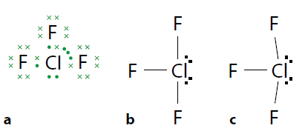
Bonding pairs=3, non-bonding pairs=2, electron domains= 5 Shape is T- Shaped or arrow shaped
I₃⁻
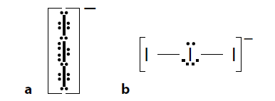

XeF₄

BrF₅
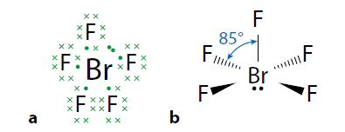

Resonance and delocalisation
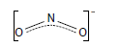
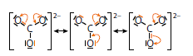

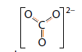
BOND ORDER = 1.3

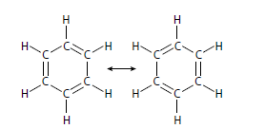
Kekule’
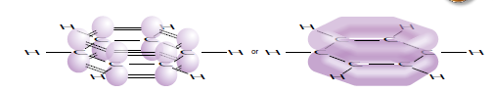
Sigma and pi bonds- Atomic orbitals overlap to form two types of covalent bond: sigma and pi
The sigma (σ) bond (Head-on overlap) single bonds
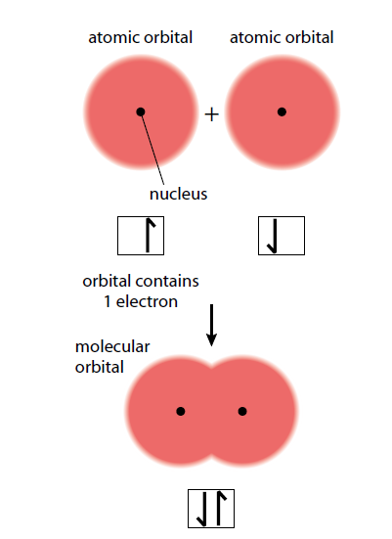

The pi (π) bond side-on overlap of parallel orbitals

Ethene

The electron density in the π bond lies above and below the internuclear axis.
A triple bond consists of one σ bond and two π bonds. Ethyne
Resonance and delocalization
The Lewis structure for O₃ with expected bond lengths.

Delocalisation is the sharing of a pair of electrons between three or more atoms. The delocalised system can be shown using dashed lines between atoms.
Bond order
Because the π bond in ozone is shared between two O–O bonds rather than just one, we consider that each bond has a half share of it, and we talk about ozone having a bond order of 1.5.
Carbonate ion

Benzene
Kekule’ benzene
The sigma framework of benzene
Delocalization over the whole benzene molecule
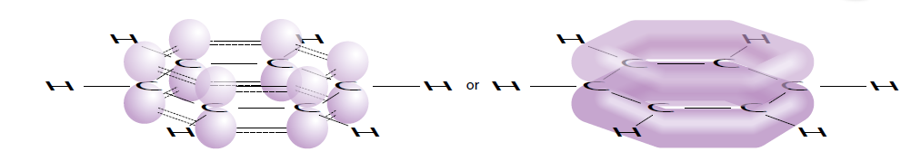

Absorption of ultraviolet light in the atmosphere
Ozone (O₃) and oxygen (O₂) are important in protecting the surface of the Earth from the damaging effects of ultraviolet radiation. The ‘ozone layer’ is a region in the stratosphere where there is a higher concentration of ozone. Even in the ozone layer, the concentration of ozone is very low.
Ultraviolet (UV) light from the Sun reaching the Earth can be divided into three components:
- UV-C λ < 280 nm (highest energy)
- UV-B λ = 280–320 nm
- UV-A λ = 320–400 nm

Absorption of UV radiation in the atmosphere.

Catalysis of ozone depletion by CFCs and NO_{x}
These compounds produce highly reactive free radicals that catalyse the decomposition of ozone to oxygen.
NO_{X}
Nitrogen monoxide, NO, is produced in vehicle engines by direct combination of nitrogen and oxygen from the air at high temperatures. It is a free radical as it has an odd number of electrons
Equations for oxidation of NO
NO· (g) + O₃ (g) → NO₂· (g) + O₂ (g)
NO₂· (g) + O· (g) → NO· (g) + O₂ (g)
NO· (g) has acted as a catalyst because it is regenerated during the reaction and the net change is the breakdown of ozone: O₃ (g) + O· (g) → 2O₂ (g)
Chlorofluorocarbons
Chlorofluorocarbons were widely used in aerosols, refrigerants, solvents, and plastics due to their low reactivity and low toxicity in the troposphere.
Freon a CFC, undergoes photochemical decomposition as follows:
CCl₂F₂ (g) → CClF₂· (g) + Cl· (g) uv is absorbed
The weaker C–Cl bond breaks in preference to the C–F bond, and the chlorine radicals catalyse the decomposition of ozone.
Cl·(g) + O₃(g) → O₂(g) + ClO·(g)
ClO·(g) + O·(g) → O₂(g) + Cl·(g)
Here Cl·(g) has acted as a catalyst and the net reaction is again:
Net effect
If two free radicals collide,
Cl·(g) + Cl·(g) → Cl₂
Probability rare due low concentration compared to O₃
O₃(g) + O·(g) → 2O₂(g)
These reactions, and others like them, have upset the balance of the ozone cycle.

14.2 Hybridization
Learning objectives
- Understand what is meant by hybridisation
- Predict the hybridisation of atoms in a molecule
Understandings:
- A hybrid orbital results from the mixing of different types of atomic orbitals on the same atom.
Inquiry: Carbon has a ground state electron configuration 1s²2s²2px¹2py¹. How does it form four similar covalent bonds in methane?
The process of excitation explains how carbon is able to form four covalent bonds but the orbitals are not all the same: there is one s orbital, and three p orbitals at a slightly higher energy.

How come all the bonds in methane are equal.
Hybridisation is the mixing of atomic orbitals in a particular atom to produce a new set of orbitals (the same number as originally) that have characteristics of the original orbitals and are better arranged in space for covalent bonding
sp³ hybridization
When carbon forms four single bonds, it undergoes sp³ hybridization, producing four equal orbitals.

Sp² hybridization
When carbon forms a double bond, it undergoes sp² hybridization, producing three equal orbitals.
These orbitals orientate themselves at 120°, forming a triangular planar shape.
For example, ethene, C₂H₄.

sp hybridization
When carbon forms a triple bond, it undergoes sp hybridization, producing two equal orbitals.
These orbitals orientate themselves at 180°, giving a linear shape. Overlap of the two hybrid orbitals with other atomic orbitals forms two sigma bonds.
For example, ethyne, C₂H₂.

Determining the hybridisation of an atom in a molecule or ion
Relationship between hybridisation and basic shape.
What is the hybridization in the following molecules?
The hybridisation scheme adopted in a molecule depends on the shape of the molecule.

Hybridisation of central atoms.

