Newton’s Law Classical Physics Problems

1. What average net force is required to stop a 7 kg shopping cart in 2 s if it’s initially traveling at 3.5 m/s?
2. At the surface of Mars the acceleration due to gravity is 3.8 m/s2. A book weighs 34 N at the surface of the Earth. What is its mass on the earth’s surface? What are its mass and weight on Mars’s surface?
3. Two blocks, with masses m1 = 400 g and m2 = 600 g, are connected by a string and lie on a frictionless tabletop. A force F = 3.5 N is applied to block m2.

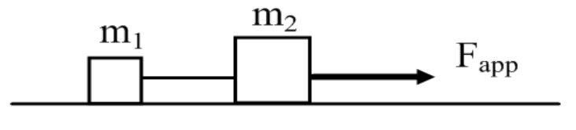

* 1. Draw a free-body diagram for each block showing all applied forces to scale. Next to each diagram show the direction of the acceleration of that object.
  2. Find the acceleration of each object.
  3. Find the tension force in the string between two objects.

1. A 180 kg motorcycle travels in a straight line on a horizontal road. The relationship between motorcycle’s velocity and time are given by the above graph.
   1. What is the acceleration during the first 5s?
   2. What is the net force during first 5 s?
   3. What is the acceleration from 5s to 10s?
   4. Whatisthenetforcefrom5sto10s?
   5. Whatis the acceleration from 10 s to15s?
   6. What is the net force from 10s to 15s?
   7. What is the acceleration from 15 s to 25s?
   8. What is the net force from 15s to 25s?