Motion in One Dimension Summary Note

Learning Objectives
- Understand the difference between vector and scalar
  - displacement VS distance
  - velocity VS speed
- Know how to calculate displacement by using Pythagorean theorem
- Know motions diagram, and know how to extract information from different diagrams
  - Velocity VS Time
  - Acceleration VS time
- Understand kinematics equation and be able to solve problems
- Understand freefall motion
  - Motion diagram: Acceleration VS Time, Velocity VS Time

Vector and Scalar
Vector
- Contains both magnitude/seize and direction
- Direction is expressed by a negative sign “-” or a positive sign “+”.
- Usually, right/east/north/upward are expressed with a positive sign, and left/west/downward/south are expressed with a negative sign
Scalar
- Has not direction
- The value is always greater or equal to zero
Example
- A person is running at 1.5 meter per second to the left
- 1.5 meter per second is the magnitude
- To the left is the direction
- Expressed in mathematical way: -1.5m’s

Displacement and Distance
Displacement
- A vector quantity
- Final position subtracted by initial position
Distance
- A scalar quantity
- 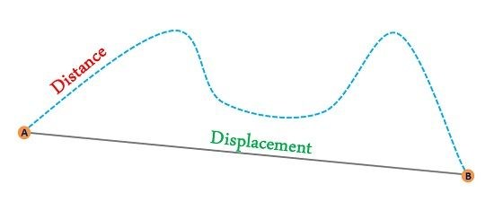

Kinematics Formula
- $a=\frac{∆v}{∆t}=\frac{(v_{f}-v_{i})}{∆t}$
- $v_{f}=v_{i}+at$
- $X_{f}=X_{i}+\frac{(v_{f}+v_{i})}{2}t$
- $X_{f}=X_{i}+v_{i}t+\frac{1}{2}at^{2}$
- ${v_{f}}^{2}={v_{i}}^{2}+2as$
For IB Student, the symbol in the test might be different. u=initial velocity, v=final velocity, s=displacement, a=acceleration

Motion Diagram
Velocity VS Time
- Area under the curve is equal to displacement
- Slope of the graph is equal to acceleration
- Constant slope means constant acceleration
- Positive slope means the acceleration is greater than zero
- Negative slope means the acceleration is less than zero = the object is decelerating
- Slope of zero means not acceleration. The object is moving at a constant velocity

Free-Fall Motion
- h=$\frac{1}{2}gt^{2}$ (gravitational acceleration g =-9.81)
- An object is dropped (initial velocity of zero) at hight h
- Hoizontal velocity of zero
- Affected by gravity only
- Gravity is equal to the object’s vertical acceleration
- Acceleration VS Time graph is constant (Acceleration=-9.81, slope is zero)
- Velocity VS time Graph has a slope of -9.81. The graph starts at its origin
