3. Periodicity

3.1 Essential ideas
- The arrangement of elements in the Periodic Table helps to predict their electron configuration.
- Elements show trends in their physical and chemical properties across periods and down groups.

Learning objectives

- Understand how the elements in the periodic table are arranged
- Understand the terms group and period
- Understand how the electron configuration of an element relates to its position in the periodic table
- Understand trends in atomic radius, ionic radius, first ionisation energy, electron affinity and electronegativity across a period
- Understand trends in atomic radius, ionic radius, first ionisation energy, electron affinity and electronegativity down a group

Understandings:
- The Periodic Table is arranged into four blocks associated with the four sub-levels: s, p, d, and f.
- The Periodic Table consists of groups (vertical columns) and periods (horizontal rows).
- Vertical and horizontal trends in the Periodic Table exist for atomic radius, ionic radius, ionization energy, electron affinity, and electronegativity.

Introduction
The Periodic Table is the ‘map’ of chemistry and is a remarkable demonstration of the order of the subject.
It was first proposed in 1869 by the Russian chemist Dmitri Mendeleyev. The position of an element in the Periodic Table is based on the sub-level of the highest-energy electron in the ground-state atom.

3.1 The periodic table
If you have visited a large supermarket, you will appreciate the importance of a classification system. Similar products are grouped together to help you find what you want. In the same way, a chemist knows what type of element to find in different parts of the Periodic Table. The elements are placed in order of increasing atomic number.
The elements in the periodic table are arranged in order of atomic number starting with hydrogen, which has atomic number 1.
The groups are the vertical columns in the periodic table and the periods are the horizontal rows.
In the IB data booklet Periodic Table the main groups are numbered from 1 to 18.
Elements whose valence electrons occupy an s sub-level make up the s block, elements with valence electrons in p orbitals make up the p block, and the d block and f block are similarly made up of elements with outer electrons in d and f orbitals.

1 2 3 4 5 6 7 8 9 10 11 12 13 14 15 16 17 18
4
7
6
5
3
2
1
H  1 |  |  |  |  |  |  |  |  |  |  |  |  |  |  |  |  | He  2
Li  3 | Be  4 |  |  |  |  |  |  |  |  |  |  | B  5 | C  6 | N  7 | O  8 | F  9 | Ne  10
Na  11 | Mg  12 |  |  |  |  |  |  |  |  |  |  | AI  13 | Si  14 | P  15 | S  16 | CI  17 | Ar  18
K  19 | Ca  20 | Sc  21 | Ti  22 | V  23 | Cr  24 | Mn  25 | Fe  26 | Co  27 | Ni  28 | Cu  29 | Zn  30 | Ga  31 | Ge  32 | As  33 | Se  34 | Br  35 | Kr  36
Rb  37 | Sr  38 | Y  39 | Zr  40 | Nb  41 | Mo  42 | Tc  43 | Ru  44 | Rh  45 | Pd  46 | Ag  47 | Cd  48 | In  49 | Sn  50 | Sb  51 | Te  52 | I  53 | Xe  54
Cs  55 | Ba  56 | La  57 | Hf  72 | Ta  73 | W  74 | Re  75 | Os  76 | Ir  77 | Pt  78 | Au  79 | Hg  80 | TI  81 | Pb  82 | Bi  83 | Po  84 | At  85 | Rn  86
Fr  87 | Ra  88 | Ac  89

- Some elements, such as Si, Ge and Sb, that have some of the properties of both metals and non-metals are called metalloids and are shaded green.
- All elements that are solid at room temperature and pressure are shown in black
- Those that are gases are in blue and liquids are in red.
- The atomic numbers jump from 57 at La (lanthanum) to 72 at Hf (hafnium). This is because some elements have been omitted – these are the lanthanoid elements.
- The actinoid elements, which begin with Ac (actinium), have also been omitted from the periodic table above.

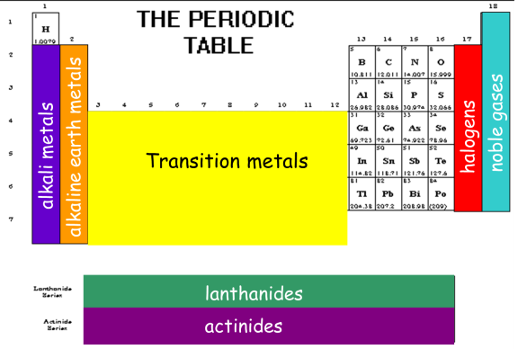
Periodic Groups
- alkali metals
- alkaline earth metals
- transition metals
- halogens
- noble gases
- lanthanides
- actinides

- Fill in the table below with the period and group numbers as they are listed on the IB Periodic Table of Elements:
Element | Period (#) | Group (# and name if appropriate)
Helium
Chlorine
Barium
Francium

- How many valence electrons are present in the atoms of the element with atomic number 51?

The periodic table and electron configurations
Electrons in the outer shell (the highest main energy level) of an atom are sometimes called valence electrons.
The group number of an element is related to the number of valence electrons.
For elements in groups 1 and 2 the group number is the same as the number of valence electron, for groups 13 –18, the number of valence electrons is given by (group number –10); so, the elements in group 13 have three valence electrons and so on.
The period number indicates the number of shells (main energy levels) in the atom.
The periodic table blocks are according to the highest energy subshell (sub-level) occupied by electrons.
Example of sulfur.
It is in period 3 and group 16, and so has three shells (the highest occupied shell is the third) and 16 – 10 = 6 electrons in its outer shell. It is in the p block – therefore its highest energy occupied subshell is a p subshell and the outer shell electron configuration is 3s²3p⁴.

3.2 Periodic trends
Physical properties
The concept of effective nuclear charge is helpful in explaining trends in both physical and chemical properties. The nuclear charge of the atom is given by the atomic number and so increases by one between successive elements in the table, as a proton is added to the nucleus. The presence of the inner electrons shields and reduces the attraction of the nucleus for the outer electrons. The effective charge ‘experienced’ by the outer electrons is less than the full nuclear charge. Across the period from left to right, one proton is added to the nucleus and one electron is added to the valence electron energy level. The effective charge increases with the nuclear charge as there is no change in the number of inner electrons.
Down the group, the increase in the nuclear charge is largely offset by the increase in the number of inner electrons; both increase by eight between successive elements in the group. There is no change in effective nuclear charge down a group.

- Atomic radius
The atomic radius is usually taken to be half the internuclear distance in a molecule of the element.
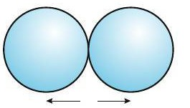
r2r
Atomic radius of chlorine in Cl₂
For many purposes, however, it can be considered as the distance from the nucleus to the outermost electrons of the Bohr atom.
- The atomic radii increase down a group, as the number of occupied electron shells (given by the period number) increases.
- There is a general decrease in atomic radii across the period. The attraction between the nucleus and the outer electrons increases as the nuclear charge increases.

- Ionic radius

In general, the ionic radii of positive ions are smaller than their atomic radii, and the ionic radii of negative ions are greater than their atomic radii.

The atomic and ionic radii of the Period 3 elements are shown in the table below.

Identify 5 trends in the table.

- First ionisation energy
The full definition of first ionisation energy is: the energy required to remove one electron from each atom in one mole of gaseous atoms under standard conditions.

M(g) → M⁺(g) + e⁻

Variation in first ionisation energy down a group
Down any group in the periodic table, the first ionisation energy decreases. Explain.
The size of the atom increases down the group so that the outer electron is further from the nucleus and therefore less strongly attracted by the nucleus although the nuclear charge also increases down a group.

Variation in first ionisation energy across a period
The general trend is that first ionisation energy increases from left to right across a period. This is because of an increase in nuclear charge across the period.

The nuclear charge increases from Na (11+) to Ar (18+) as protons are added to the nucleus. The electrons are all removed from the same main energy level (third shell) and electrons in the same energy level do not shield each other very well. Therefore, the attractive force on the outer electrons due to the nucleus increases from left to right across the period.

The increase in first ionisation energy can also be explained in terms of the effective nuclear charge felt by the outer electron in argon being higher. The effective nuclear charge felt by the outer electron in a sodium atom would be 11 (nuclear charge) − 10 (number of inner shell electrons), i.e., 1+ if shielding were perfect. The effective nuclear charge felt by the outer electrons in an argon atom would be 18 (nuclear charge) − 10 (number of inner shell electrons), i.e., 8+ if shielding were perfect.

- Electron affinity
The first electron affinity involves the energy change when one electron is added to a gaseous atom:
X(g) + e⁻ → X–(g)

Electron affinity is difficult to measure experimentally and data are incomplete.
The first electron affinity is exothermic for virtually all elements – it is a favourable process to bring an electron from far away (infinity) to the outer shell of an atom, where it feels the attractive force of the nucleus.
The second and third electron affinities are defined similarly. The second electron affinity for oxygen, for example, corresponds to the change:
O–(g) + e– → O2–(g)
This process is endothermic as the added electron is repelled by the negatively charged oxide (O–) ion, and energy needs to be available for this to occur. Electron affinities can be thought of as the negative of first ionization energy of the anion.
- The Group 17 elements have incomplete outer energy levels and a high effective nuclear charge of approximately +7 and so attract electrons the most.
- The Group 1 metals have the lowest effective nuclear charge of approximately +1 and so attract the extra electron the least.

- Electronegativity
Electronegativity is a measure of the attraction of an atom in a molecule for the electron pair in the covalent bond of which it is a part.

An element with a high electronegativity has strong electron pulling power and an element with a low electronegativity has weak pulling power. The concept was originally devised by the American chemist Linus Pauling and his values are given in the IB data booklet (Section 8). The general trends are the same as those for ionization energy.

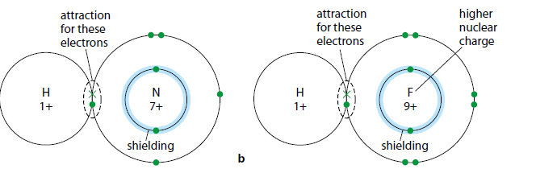

- Electronegativity increases from left to right across a period owing to the increase in nuclear charge, resulting in an increased attraction between the nucleus and the bond electrons.
- Electronegativity decreases down a group. The bonding electrons are furthest from the nucleus and so there is reduced attraction.
Pauling assigned the highest value of 4.0 to fluorine and the lowest value of 0.7 to caesium.

Metals have lower ionization energies and electronegativities than non-metals
The ability of metals to conduct electricity is due to the availability of their valence electrons to move away from the atomic nucleus. This can be related to their low ionization energies and electronegativities.
A metallic structure consists of a regular lattice of positive ions in a sea of delocalized electrons.

In general, metallic elements tend to have large atomic radii, low ionisation energies, less exothermic electron affinity values and low electronegativity.

Tin has a non-metallic allotrope (grey tin) and prolonged exposure of tin to low temperatures can bring about the transformation to the brittle non-metallic form. The transformation is sometimes called ‘tin pest’ and there are tales (not necessarily true!) that Napoleon lost the Russian campaign in 1812 because his soldiers had buttons made of tin – in the cold Russian winter the buttons became brittle and their trousers fell down!

