Stoichiometric relationships
Introduction to the particulate nature of matter and chemical change
Learning objectives
- Describe the three states of matter
- Understand the changes involved when there is a change in state
The three states of matter are solid, liquid and gas and these differ in terms of the arrangement and movement of particles. The particles making up a substance may be individual atoms or molecules or ions.
- Sublimation
Sublimation is the change of state when a substance goes directly from the solid state to the gaseous state, without going through the liquid state. Examples: Both iodine and solid carbon dioxide (dry ice) sublime at atmospheric pressure.
In the same way write short notes on the following:
- Deposition
Deposition is the change of state when a substance goes directly from gas to solid
- Melting
Melting is the change of when a substance goes from solid to liquid
- Evaporation
evaporation is the change of state when a substance goes from liquid to gas
- Condensing
Condensation is the change of state when a substance goes from gas to liquid
Complete the following table to show properties of matter
 | Solid | Liquids | Gases
Distance between particle | close together | close but further apart than in solids | particles far apart
Arrangement | Fixed, lattice arrangement | random | random
Shape | fixed shape | No fixed shape | No fixed shape
Volume | Fixed volume | fixed | not fixed
Movement | vibrate | move around each other | Move around all direction
Speed of movement | faster | Faster than solids, but slower than gases | fastest
Energy | lowest | higher | highest
Forces of attraction | strongest | weaker | weakest

Draw a heating curve showing changes of state for a pure substance heated slowly, from below its melting point to above its boiling point. Explain the changes on the graph showing change of state.
Temperature remains constant value at the temperature of charge of state.
- Heat energy is being used to overcome intermolecular forces, separating particles. Average KE remains constant, but PE energy increases.

Chemical change
Learning objectives
- Understand that compounds have different properties to the elements they are made from
- Understand how to balance chemical equations
- Understand how to use state symbols in chemical equations
- Describe the differences between elements, compounds and mixtures
- Understand the differences between homogeneous and heterogeneous mixtures
Elements and compounds
Gold is an element and all samples of pure gold contain only gold atoms.
An element is a pure substance that contains only one type of atom.
An atom is the smallest part of an element that can still be recognized as that element.
The physical and chemical properties of a compound are very different to those of the elements from which it is formed.
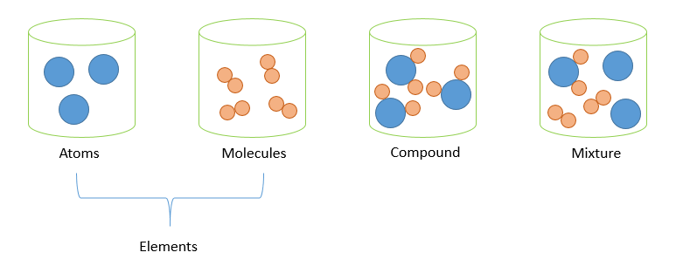
Sodium and chlorine are elements. When they are mixed and heated they combine chemically to form a compound called sodium chloride. Use this to illustrate the statements above.
Chlorine is a gas
- does not conduct electricity
- poisonous
- yellowish, green color
- pungent smell
Sodium
- Soft, grey metals
- React with water
Sodium chorine
- Neutral salt, used as table salt

The meaning of chemical equations
When elements combine to form compounds, they always combine in fixed ratios depending on the numbers of atoms required.
Chemical equation
- Why balance chemical equation?
  - because of conversation of mass and energy
  - to be efficient in utilization of limited resources
  - predict and develop new products
Give an example to show how much of sodium reacts with chlorine to form sodium chloride (Use data booklet).

Balancing equations
When a chemical reaction is represented by a chemical equation, there must be exactly the same number and type of atoms on either side of the equation, representing the same number of atoms before and after this reaction:
Example C ₃H₈ + 5O₂ → 3CO₂ + 4H₂ O
Only coefficients (large numbers in front of the substances) may be added to balance a chemical equation.
State symbols are often used to indicate the physical state of substances involved in a reaction:
(s) = solid
(l) = liquid
(g) = gas
(aq) = aqueous (dissolved in water)

Write balanced equations for the following chemical reactions.
(a). reaction between nitrogen and hydrogen to form ammonia.
$$N_{2}+{3H}_{2}-->{2NH}_{3}$$
- Ammonia is used in an industrial process of Harber process
- Ammonia is used to produce fertilizer
(b). butane burns in plenty of air to form carbon (IV) oxide and water.
$$C_{4}H_{10}+13O_{2}-->{4CO}_{2}+{5H}_{2}O$$
- Butane is the sources of thermal energy
(c ). Write an equation for the reaction of thermal decomposition of sodium hydrogencarbonate (NaHCO₃) into sodium carbonate (Na₂CO₃), water (H₂O), and carbon dioxide (CO₂)
2NaHCO₃ Na₂CO₃ + H₂O + CO₂
(c). 4CrO₃ → 2Cr₂ O₃ +3 O₂
(d). 2H₂O₂ → O₂ + 2H₂O
(e). 4PH₃ + 8O₂ → P₄O₁₀ + 6H₂O

Mixtures
The components of a mixture are not chemically bonded together and so retain their individual properties. A mixture contains two or more substances mixed together. The components of a mixture can be separated from each other by physical means – for example a mixture of sand and salt could be separated by dissolving the salt in water, filtering off the sand and then heating the salt solution to drive off the water.
Homogeneous and heterogeneous mixtures
A homogeneous mixture has the same (uniform) composition throughout the mixture and consists of only one phase.
- Particle of a homogeneous mixture experience the same phase
One example of a homogeneous mixture is a solution. Clean air (with no particulates) is also a homogeneous mixture.
A heterogeneous mixture does not have uniform composition and consists of separate phases. Heterogeneous mixtures can be separated by mechanical means.
- Particles of a heterogeneous mixture experience different phases
One example of a heterogeneous mixture is sand in a beaker of water. Mixtures of different solids are also heterogeneous.
Study mixtures to study the best way of separation
- For example: crude oil, catalyst
- Catalyst can be homogeneous and heterogeneous. It is hard to differentiate to catalyst and products if the catalyst is homogeneous.
International mindedness
Ocean oil spills are usually the result of accidents in the industries of oil extraction or transport. The release of signiﬁcant volumes of oil causes widespread damage to the environment, especially wildlife, and can have a major impact on local industries such as ﬁshing and tourism. Efforts to reduce the impact of the spill include the use of dispersants, which act somewhat like soap in helping to break up the oil into smaller droplets so it can mix better with water. Concern is expressed, however, that these chemicals may increase the toxicity of the oil and they might persist in the environment. The effects of an oil spill often reach countries far from the source and are the subject of complex issues in international law. With the growth in demand for offshore drilling for oil and projected increases in oil pipelines, these issues are likely to become all the more pressing.
A fourth state of matter, plasma, exists only at conditions of very high temperatures and pressures, such as are commonly found in space. It is characterized by atoms that have been stripped of their electrons, and so exist as positively charged ions in loose association with their electrons. Plasma is a ﬂuid, like liquid and gas, but also generates electromagnetic forces due to the charged particles present. All matter in the stars, including our Sun, exists in the plasma state.

