Worksheets for revision of topic 1.2 uncertainty

By the end of Subtopic 1.1 - Measurements in physics, you should be able to:
- Use SI units correctly and avoid the use of non-SI units.
- List the fundamental units used in IB physics.
- Derive units by multiplying or dividing familiar units.
- Use both scientific notation and metric multipliers interchangeably.
- Distinguish between an estimation and a measurement.
- Give a measurement to the appropriate number of significant figures depending upon the instruments used.
- Round off a calculator display to the appropriate number of significant figures given the strength of the data used.
- Give the order of magnitude of a ratio.

A car has a mass of 1000kg. A mouse has a mass of 10g. What is the order of magnitude of the ratio between the mass of the car to that of the mouse?
By how many orders of magnitude is the mass of the observable universe (10⁵⁰kg) greater than the mass of an up quark (10⁻³⁰kg)?

To how many decimal places should the answer to the calculation below be given?
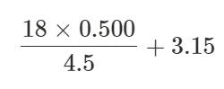
- Give a measurement to the appropriate number of significant figures depending upon the instruments used.
Digital measurement, no estimation.

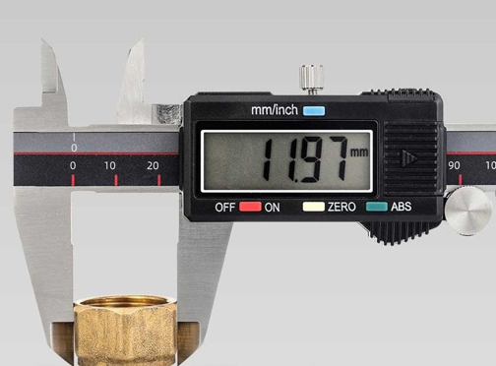
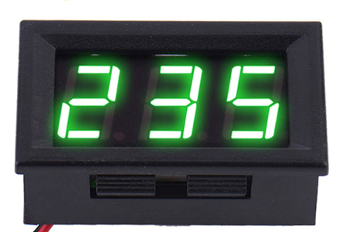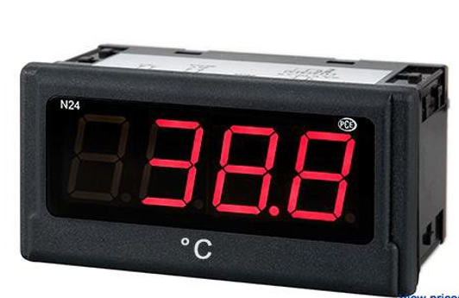

Analog, estimation to one more significant figure.
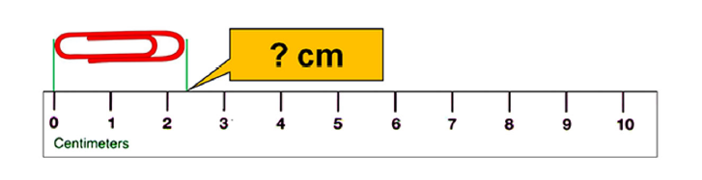
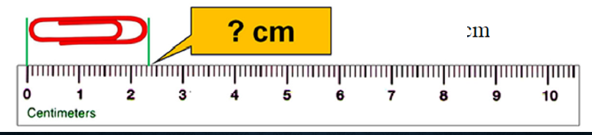

By the end of Subtopic 1.2 - Uncertainties and errors you should be able to:
- Distinguish between random and systematic errors.
- Critically appraise an experiment to suggest how to reduce such errors.
- Express uncertainties in absolute terms, or as a percentage.
- Calculate how uncertainties are propagated through the manipulation of data.
- Plot data with uncertainty bars.
- Draw a clean straight/curved line through data points, so that it passes through all uncertainty bars.
- Determine the uncertainty in gradients and also in intercepts.
1. Distinguish between random and systematic errors.
Critically appraise an experiment to suggest how to reduce such errors.
1.1 Guiding question: Determine, according to the statement, is it a systematic error or a random error.
  - an error in the apparatus or procedure:
  - the amount had been random and averaged out to zero
  - all measurements are consistently greater than the true value.
1.2 Which represents a random error and which is a systematic error?
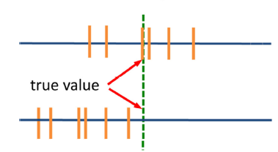
Which represents large random error and which is large systematic error?

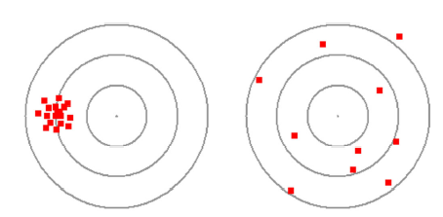
A student is investigating Hooke's law. She plots a graph of force versus extension for a spring, as shown below.
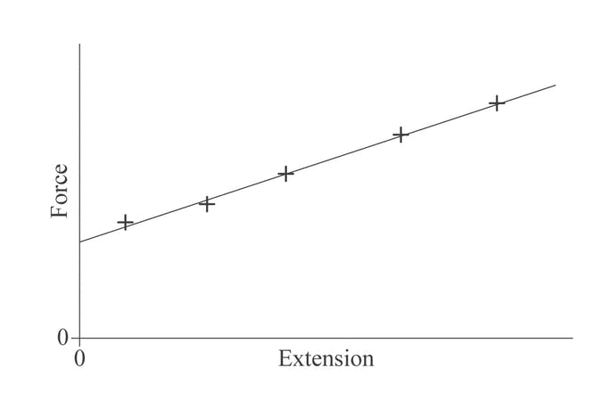
1.3 outlier
Guiding question: You take three readings of the time it takes for a ball to reach the ground from a third floor window. They are: 1.41s, 1.38s and 2.56s. What course of action should you take?

- Take the average of the three readings.
- Discard the third reading and take the average of the first two.
- Discard the third reading and take another one in its place. If it is close to the first two measurements then average the three values.
- Take a fourth reading then average all four readings.

2. Express uncertainties in absolute terms, or as a percentage.
2.1 Digital measurement, no estimation, uncertainty as the smallest division.

2.2 Analog, estimation to one more significant figure, uncertainty as half of the smallest division
2.3 Go further:
Decimal place of the measured value must be consistent with that of the uncertainty.
i.e. 30±0.1 will never happen in physics measurements.
Probing question: WHY?
What is the absolute uncertainty of the measure you made about the temperature?
The percentage?
2.4 even deeper!
You take three measurements of the height of your baby sister during the course of a day. They are 186.2cm, 185.9cm and 186.8cm. What is your best estimate of your sister's height?

3. Calculate how uncertainties are propagated through the manipulation of data.
- addition and subtraction
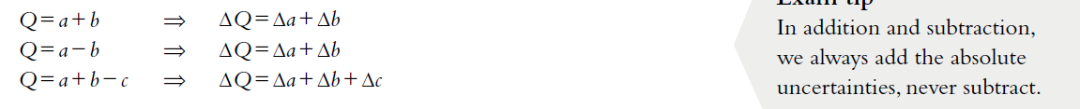
3.1 Find the percentage uncertainty in the quantity Q = a − b, where a = 538.7 ± 0.3 and b = 537.3 ± 0.5. Comment on the answer.

__________________________________________________________________________________________________

__________________________________________________________________________________________________

__________________________________________________________________________________________________
- multiplication and division
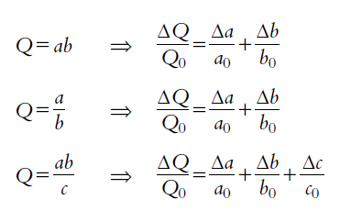
3.2 The sides of a rectangle are measured to be a = 2.5 cm ± 0.1 cm and b = 5.0 cm ± 0.1 cm. Find the area A of the rectangle.

__________________________________________________________________________________________________

__________________________________________________________________________________________________

- raising to a power.
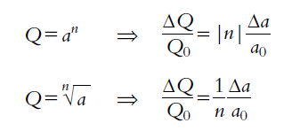
3.3 A mass is measured to be m = 4.4 ± 0.2 kg and its speed v is measured to be 18 ± 2 m s⁻¹. Find the kinetic energy of the mass.

__________________________________________________________________________________________________

__________________________________________________________________________________________________
3.4
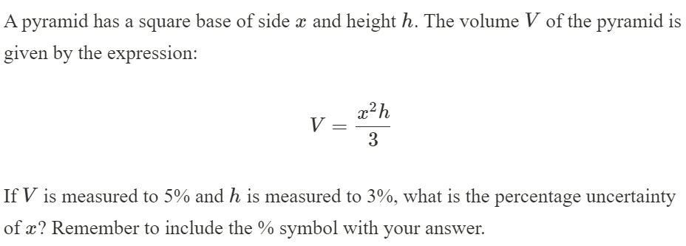

Further practice
