1. One person throws a ball horizontally from the top of the building at an initial speed of 20m/s. The horizontal displacement of the ball travelled is 40. Ignore air resistance, calculate (g= $10m/s^{2}$)
   1. The height of the building h;
   2. The velocity v of the ball when it falls to the ground;
   3. The distance between the ball's throwing point and its landing point L.
2. An aircraft is flying horizontally at an altitude of 2000m and at a constant speed of 360km/h. The aircraft drops a package directly above the observer on the ground (g is g= $10m/s^{2}$ 2, ignoring air resistance).
   1. Compare the two trajectories of the package as seen by pilots and ground observers.
   2. How far is the package from the observer on the ground and how far is it from the horizontal distance of the aircraft?
   3. Find the magnitude and direction of the velocity when the package hits the ground.
3. The ball of A and B are thrown spontaneously from a height of 15m and at an initial velocity of 10m/s. A is thrown vertically downward, while B is thrown horizontally with no air resistance. Given that gravitational acceleration is equal to $10m/s^{2}$.
   1. Calculate the time for ball A to reach ground
   2. The distance between ball A and ball B when they both reach the ground
4. 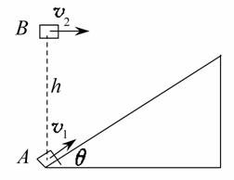As shown in the figure, an inclined plane with a smooth surface and an Angle of θ = 37° is fixed on the horizontal ground. Object A slides along the inclined plane with an initial velocity of 6 m/s. At the same time, an object B is thrown horizontally at an initial velocity directly above the object A. If object B hits object A when it reaches the highest point. (both A and B can be regarded as particles, sin37° = 0.6, cos37° = 0.8, g is 10 m/s2).
   1. Find the time for object A to reach its maximum height
   2. Find the initial velocity of object B
   3. Find the height difference between objects A and B at their initial position
5. 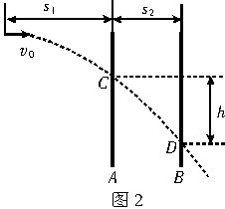A bullet is shoot from the gun. While the bullet is moving, there are two parallel and vertical barriers A and B as shown in the figure. The horizontal distance between plate A and the muzzle is S1, and the distance between the two plates is S2. The bullet passes through the two plates and leaves bullet holes C and D successively. The height difference between C and D is h. Neglect baffle and air resistance, find the initial velocity of the bullet.
6. As shown in the figure, a ball is thrown horizontally from the top of a slope with an angle of θ at an initial velocity of $V_{0}$. Regardless of air resistance. If the inclined plane is long enough, how long does it take for the ball to leave the slope the maximum distance? What is the maximum distance?