Time: 50 Minutes, Total Mark
Multiple Choice
- one point or each question
- The shape of the curve vertical displacement versus time is ___
- Parabolic function
- A concave up quadratic function
- A linear function
- None of the above
- When an object is in free fall, its vertical velocity__ _with time, and its horizontal velocity ___with time
- decreases, increases
- decreases, decrease
- increase, does not change
- increase, decreases
- When an object is in free fall, its vertical speed__ _with time, and its horizontal speed ___with time
- decreases, increases
- decreases, decrease
- increase, does not change
- increase, decreases
- When an object is in free fall motion, the theoretical slope of the graph vertical speed versus time should be ___
- -9.81
- 9.81
- 7.84
- 12.34
Free Response Part 1
- (2 points for each question)
- What is the difference between a vector and a scalar?

- What does the gradient (slope) of the graph displacement versus time represents?

- When an object is in free fall, its graph of vertical velocity versus time maintains a theoretical slope of negative 9.81. Explain why

- With the same condition of problems 3, explain why the gradient might be less than negative 9.81.
Free Response Part 2
- Five points for each question
- A ball rolls down a 445 m slope from rest. If it accelerates at a rate of 3.16 ms–2, determine the time it takes to reach the bottom of the slope and the ball’s final velocity.

- Two balls are 8.0 metres apart and moving directly towards each other. If the first ball is moving at a speed of 2.5 ms–1 with respect to the ground and the second ball 3.5 ms–1 with respect to the ground, where will they collide?

- A helicopter is ascending at a constant speed of 12 ms–1 and drops a package from a height of 64 m. How long will it take the package to reach the ground? Assume there is no air resistance.

- A football is kicked from the ground with an initial speed of 16 ms–1 at an angle of 24° to the horizon. At what two times will the ball have a height of 1.0 m? Assume the kick happens at t = 0 s.

- A rock is thrown from the top of a 36 m high cliff with an initial speed of 12 ms–1 at an angle of 52° to the horizon. How long will it take the rock to reach the bottom of the cliff?

Challenges Question
- Four points for each question

- The below graph shows the vertical position of an object. Find the total horizontal displacment what object travelled.
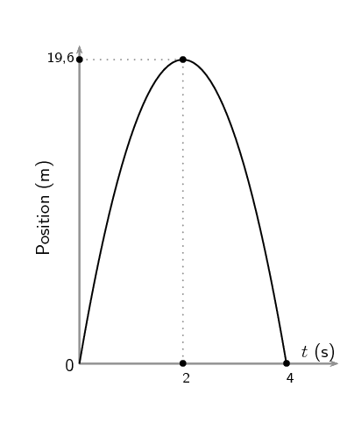
- A teacher is doing an investigation about projectile motion with her students in a classroom. The teacher uses a projectile launcher and launch a steel ball vertical upward. The steel ball reaches a maximum height of 163 centimeters in 12 seconds.

  - Then the teacher puts the projectile launcher one a seat, so that the projectile launcher is 10 centimeters above the seat and the seat is 80 centimeters away above the ground level. Then she takes a foam box with length of 50 centimeters, width of 20 centimeters, and thickness of 5 centimeters. The students want to know where should they place and foam box so that the steel ball can be fall into it.

  - The teach puts the projectile launcher on ground and launch the steel ball at an angle of 30 degrees. The students measure the distance between the projectile launcher and the ground. The launcher is 15 centimeters above the ground. Where should the students place the foam box?

  - The teacher puts the machine on the seat again, and the launcher launch the steal ball at the same angle (30 degrees). Where should the students place the foam box?

