**6.2 Rate expression and reaction mechanism (HL)**

**6.2.1 The rate equation/rate expression**

**Learning objectives**

• Explain the terms rate constant and order of reaction

• Work out the rate expression (rate equation) from numerical data and solve problems related to it

• Sketch and explain graphs of concentration against time and rate against time for zero-, first-and second-order reactions

A rate of reaction is usually affected by a change in concentration of the reactants.

Consider the reaction A → B. If a series of experiments is carried out in which the concentration of A is varied and the rate of reaction measured plotted against concentration is a straight line through the origin, the rate of reaction is directly proportional to the concentration of A.

rate ∝ [A]

where [A] is the concentration of A.

so, rate =k[A]

This equation is called a **rate equation** or **rate expression** – *k* is called the **rate constant**. A rate equation is also called a rate law.



**The rate equation is an experimentally determined equation that relates rate of reaction to the concentrations of substances in the reaction mixture in a series of experiments.**

For example, for the reaction:

W + X → Y + Z we can write: **rate = *k*[W]*m*[X]*n***

The rate constant is only a constant for a particular reaction at a chosen temperature. The powers m and n are called order of the reaction.

In the rate equation above, the order with respect to W is *m* and the order with respect to X is *n*. The overall order is *m* **+** *n*.

If rate =k[A], this reaction is first order with respect to A and first order overall.

Fractional orders are only found in complex chain reactions. For example,the pyrolysis of ethane to ethene and hydrogen:

C2H6(g) → C2H4(g) + H2(g) involves a complex chain reaction and has a rate equation of the form:

rate = k[C2H6]1/2.

**Experimental determination of a rate equation**

For the reaction A + B → C, the dependence of the reaction rate on the concentrations of A and B can be determined by conducting the following set of experiments. The initial rate is taken because this is the only point at which we know the concentration of A and concentration of B – none has been used up.

1. A series of experiments is carried out using a fixed amount of B and changing the concentration of A each time. Plot a graph of concentration of A against time and find the initial rates. Plot a graph of initial rate against concentration of A to find the reaction order with respect to A.
2. Next, the experiments are repeated using a fixed amount of A and varying the concentration of B. This allows the order of reaction with respect to B to be calculated.
3. Use the orders with respect to A and B to find the rate equation, and hence a value for the rate constant.

Example 1:

Consider the data for the reaction 2A → B, given in Table below to find;

a.the order with respect to A

**b.**the rate equation

**c.**the value of the rate constant (with units)

**d.**the rate of reaction when [A] = 1.3 mol dm−3.

|  |  |  |
| --- | --- | --- |
| Experiment | **[A] / mol dm−3** | **Rate / mol dm−3 s−1** |
| 1 | 1.0 | 0.60 |
| 2 | 2.0 | 1.20 |
| 3 | 5.0 | 3.00 |

Example 2





Example 3



Graphical representations of reaction kinetics

Zero-order reaction

Here the concentration of reactant A does not affect the rate of the reaction.

rate = *k*[A]0 or rate = *k*

For example,the decomposition of ammonia on a tungsten surface:

2NH3(g) → N2(g) + 3H2(g)

The concentration of ammonia decreases at a constant rate in this reaction.

So the concentration–time graph is a straight line, showing a constant rate. The gradient of the line = *k*. The rate–concentration graph is a horizontal line.

a

b

rate

Concentration

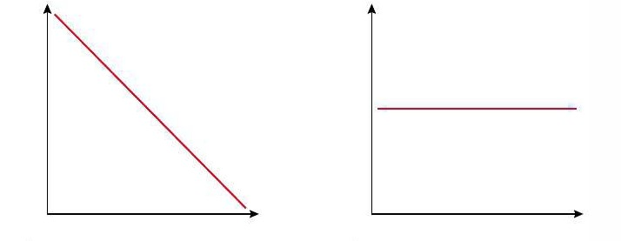

time

concentration

Changing the concentration of ammonia has no effect on the rate of the reaction (b).

The rate equation is rate = *k*, which shows that the rate is constant.

The units of the rate constant are the same as the rate: *concentration × time−1.* A set of units for the rate constant could therefore be mol dm−3 s−1.

First-order reaction

Here the rate is directly proportional to the concentration of A.

rate = *k*_[A]

So the concentration–time graph is a curve showing rate decreasing with concentration , the rate–concentration graph is a straight line passing through the origin with gradient *k*

b

a

rate

concentration

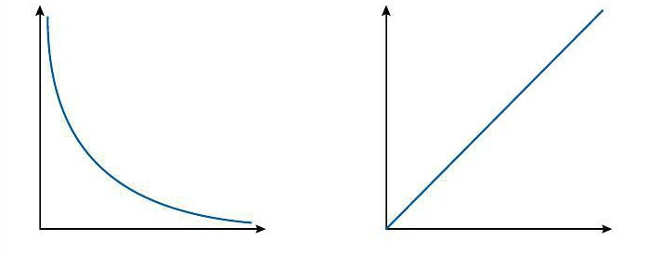

time

concentration

For example the decomposition of hydrogen iodide on a platinum surface:

2HI(g) → H2(g) + I2(g)

The rate of this reaction is directly proportional to the concentration of HI, as shown by the straight line through the origin (b).

The graph in Fig (a) shows how the concentration of HI decreases with time. This shows an exponential decay and a constant **half-life**. The time taken for the concentration to drop by half does not depend on concentration in a first-order reaction.

**The rate equation for this reaction is: rate = *k*[HI].**

**The units of *k* are time−1.**

Second-order reaction

Here the rate is proportional to the square of the concentration of A.

rate = *k*[A]2

So the concentration–time graph is also a curve, steeper at the start than the first-order graph and levelling off more. The rate–concentration graph is a parabola, characteristic of the square function. The gradient here is proportional to the concentration and is initially zero.

Rate

Concentration

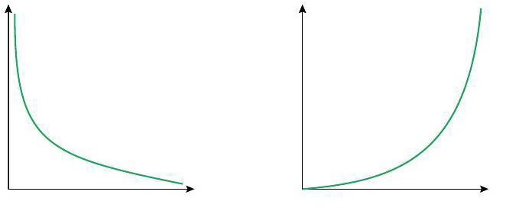

time

concentration

a b

Example: the decomposition of hydrogen iodide without a catalyst:

2HI(g) → H2(g) + I2(g)

It can be proved that a reaction is second order (rather than third order, etc.) by plotting a graph of rate against concentration of HI squared. As the rate is proportional to [HI]2, this graph is a straight line through the origin.

**The rate equation for this reaction is rate = *k*[HI]2.**

**The units of the rate constant are concentration−1 time−1 (i.e. units could be mol−1 dm3 s−1).**



For a zero-order reaction, the units of *k* are the same as that of the rate. Each time the overall order increases by 1 the units of *k* are divided by concentration.