**1.3 Calculations involving solutions**

**Solute**: a substance that is dissolved in another substance.

**Solvent:** a substance that dissolves another substance (the solute). The solvent should be present in excess of the solute.

**Solution:** the substance that is formed when a solute dissolves in a solvent.

**Why is concentration defined in terms of solution and not the solvent?**

When a solute is dissolved in a certain volume of water, the total volume of solution produced depends on the forces of attraction between the solute particles and the solvent particles compared with the forces of attraction in the original solvent. This is why concentration is defined in terms of the volume of the solution rather than the volume of the solvent.

**What is concentration?**

The concentration of a solution is the amount of solute dissolved in a unit volume of solution. The volume that is usually taken is 1 dm3. The amount of solute may be expressed in g or mol therefore the units of concentration are g dm−3 or mol dm−3.

2 M solution refer to a ‘2 molar solution’ or a solution of concentration 2 mol dm−3.

* Concentration (mol dm−3) = or c= , n=cV
* Concentration (g dm−3) =

Dilutions of solutions reduce the concentration

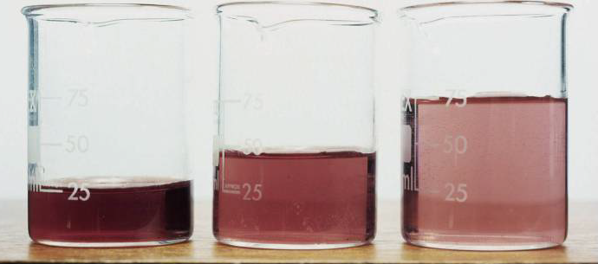

As a solution is diluted, the number of moles of solute remains the same, but as they become spread through a larger volume, the concentration is decreased.

So, *cV* must be constant and ***c*1*V*1 = *c*2*V*2 =n**; where *c*1 and *V*1 refer to the initial concentration and volume and *c*2 and *V*2 refer to the diluted concentration and volume.

**Concentrations of very dilute solutions**

Very small concentrations can be expressed in the unit *parts per million*, *ppm*. For example if 1 g of a solute is present in 1 million grams of a solution then the concentration is 1 ppm. The ppm notation is most often used when writing about pollution

Example: Determine the final concentration of a 75 cm3 solution of HCl of concentration

0.40 mol dm–3, which is diluted to a volume of 300 cm3.

*c*1*V*1 = *c*2*V*2

(0.40 mol dm–3) (75 cm3) = *c*2 (300 cm3),

diluted concentration = 0.10 mol dm–3

The concentration of a solution can be determined by volumetric analysis

Most commonly, a technique called **titration** is used to determine the reacting volumes precisely. A

**pipette** is used to measure a known volume of one of the solutions into a **conical flask.** The other solution is put into a **burette**.

The concentration of one of the solutions reacting must be known accurately – this is a standard solution and is prepared in a volumetric flask.

The point at which the two solutions have reacted completely, the **equivalence point**, is usually determined by an **indicator** that is added to the solution in the conical flask and changes colour at its **end-point**. Different indicators are chosen for specific titrations, so that their end-point corresponds to the equivalence point of the titration.

***Burettes generally read to ± 0.05 cm3, so be sure to record your results to this precision. Readings such as 0, 12.0, or 3.5 are not acceptable but should be recorded as 0.00, 12.00, and 3.50 respectively.***

Titration usually involves multiple trials to obtain a more accurate result of the volume, (titre).

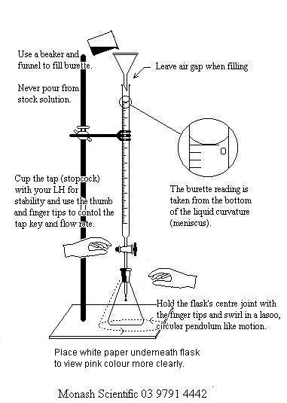

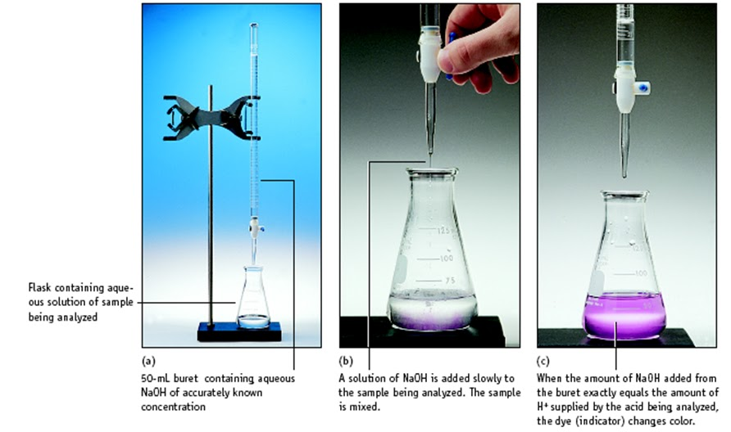

Examples:

1. Sulfuric acid is titrated against 25.0 cm3 of 0.2000moldm-3 sodium hydroxide solution. It’s found that 23.20 cm3 of sulfuric acid is required for titration. Calculate the concentration of sulfuric acid.

(0.025)(0.2)=2(0.023)C

C=0.1087

Step 1 write a balanced chemical equation and calculate the number of moles for the known concentration:

H2SO4 + 2 NaOH → Na2SO4 + 2H2O

|  |
| --- |
|  |

Step 2: The balanced equation tells that for every 2 moles NaOH, 1 mole H2SO4  reacts.

Step 3: Convert moles to concentration. n= CV

1. 25.00 cm3 of 0.100 mol dm–3 sodium hydrogencarbonate, NaHCO3, solution were titrated with dilute sulfuric acid, H2SO4.

2NaHCO3(aq) + H2SO4(aq) → Na2SO4(aq) + 2H2O(l) + 2CO2(g).

15.20 cm3 of the acid were needed to neutralize the solution. Calculate the concentration of the acid.

(0.0152)(C)=(0.025)(0.1)

C = 0.033

Back titration

It is used when the end-point is hard to identify or when one of the reactants is impure. A known excess of one of the reagents is added to the reaction mixture, and the unreacted excess is then determined by titration against a standard solution. By subtracting the amount of unreacted reactant from the original amount used, the reacting amount can be determined.

Examples:

1. An antacid tablet with a mass of 0.300 g and containing NaHCO3 was added to 25.00 cm3 of 0.125 mol dm–3 hydrochloric acid. After the reaction was complete, the excess hydrochloric acid required 3.50 cm3 of 0.200 mol dm–3 NaOH to reach the equivalence point in a titration. Calculate the percentage of NaHCO3 in the tablet.

68.0%

HCl + NaOH🡪NaCl + H2O

(0.00350)*(0.200)=0.000700 mole HCl unreacted

(0.025)*(0.125) = 0.00313 mole HCl for total

So 0.00313 - 0.000700 = 0.00243 mol HCl reacted

(0.00243)*(22.99+1.01++12+48) = 0.204g

0.204/0.300 = 68.0%

1. Limestone is impure calcium carbonate (CaCO3). 2.00 g of limestone is put into a beaker and 60.00 cm3 of 3.000 mol dm−3 hydrochloric acid (HCl) is added. They are left to react and then the impurities are filtered off and the solution is made up to a total volume of 100.0 cm3. Of this solution, 25.00 cm3 require 35.50 cm3 of 1.000 mol dm−3 sodium hydroxide (NaOH) for neutralisation.

Work out the percentage calcium carbonate in the limestone (assume that none of the impurities reacts with hydrochloric acid).

**1.3 Calculations involving solutions**

**Solute**: a substance that is dissolved in another substance.

**Solvent:** a substance that dissolves another substance (the solute). The solvent should be present in excess of the solute.

**Solution:** the substance that is formed when a solute dissolves in a solvent.

**Why is concentration defined in terms of solution and not the solvent?**

When a solute is dissolved in a certain volume of water, the total volume of solution produced depends on the forces of attraction between the solute particles and the solvent particles compared with the forces of attraction in the original solvent. This is why concentration is defined in terms of the volume of the solution rather than the volume of the solvent.

**What is concentration?**

The concentration of a solution is the amount of solute dissolved in a unit volume of solution. The volume that is usually taken is 1 dm3. The amount of solute may be expressed in g or mol therefore the units of concentration are g dm−3 or mol dm−3.

2 M solution refer to a ‘2 molar solution’ or a solution of concentration 2 mol dm−3.

* Concentration (mol dm−3) = or c= , n=cV
* Concentration (g dm−3) =

Dilutions of solutions reduce the concentration



As a solution is diluted, the number of moles of solute remains the same, but as they become spread through a larger volume, the concentration is decreased.

So, *cV* must be constant and ***c*1*V*1 = *c*2*V*2 =n**; where *c*1 and *V*1 refer to the initial concentration and volume and *c*2 and *V*2 refer to the diluted concentration and volume.

**Concentrations of very dilute solutions**

Very small concentrations can be expressed in the unit *parts per million*, *ppm*. For example if 1 g of a solute is present in 1 million grams of a solution then the concentration is 1 ppm. The ppm notation is most often used when writing about pollution

Example: Determine the final concentration of a 75 cm3 solution of HCl of concentration

0.40 mol dm–3, which is diluted to a volume of 300 cm3.

*c*1*V*1 = *c*2*V*2

(0.40 mol dm–3) (75 cm3) = *c*2 (300 cm3),

diluted concentration = 0.10 mol dm–3

The concentration of a solution can be determined by volumetric analysis

Most commonly, a technique called **titration** is used to determine the reacting volumes precisely. A

**pipette** is used to measure a known volume of one of the solutions into a **conical flask.** The other solution is put into a **burette**.

The concentration of one of the solutions reacting must be known accurately – this is a standard solution and is prepared in a volumetric flask. The

The point at which the two solutions have reacted completely, the **equivalence point**, is usually determined by an **indicator** that is added to the solution in the conical flask and changes colour at its **end-point**. Different indicators are chosen for specific titrations, so that their end-point corresponds to the equivalence point of the titration.

***Burettes generally read to ± 0.05 cm3, so be sure to record your results to this precision. Readings such as 0, 12.0, or 3.5 are not acceptable but should be recorded as 0.00, 12.00, and 3.50 respectively.***

Titration usually involves multiple trials to obtain a more accurate result of the volume, (titre).





Examples:

1. Sulfuric acid is titrated against 25.0 cm3 of 0.2000moldm-3 sodium hydroxide solution. It’s found that 23.20 cm3 of sulfuric acid is required for titration. Calculate the concentration of sulfuric acid.

Step 1 write a balanced chemical equation and calculate the number of moles for the known concentration:

H2SO4 + 2 NaOH → Na2SO4 + 2H2O

|  |
| --- |
|  |

Step 2: The balanced equation tells that for every 2 moles NaOH, 1 mole H2SO4  reacts.

Step 3: Convert moles to concentration. n= CV

1. 25.00 cm3 of 0.100 mol dm–3 sodium hydrogencarbonate, NaHCO3, solution were titrated with dilute sulfuric acid, H2SO4.

2NaHCO3(aq) + H2SO4(aq) → Na2SO4(aq) + 2H2O(l) + 2CO2(g).

15.20 cm3 of the acid were needed to neutralize the solution. Calculate the concentration of the acid.

Back titration

It is used when the end-point is hard to identify or when one of the reactants is impure. A known excess of one of the reagents is added to the reaction mixture, and the unreacted excess is then determined by titration against a standard solution. By subtracting the amount of unreacted reactant from the original amount used, the reacting amount can be determined.

Examples:

1. An antacid tablet with a mass of 0.300 g and containing NaHCO3 was added to 25.00 cm3 of 0.125 mol dm–3 hydrochloric acid. After the reaction was complete, the excess hydrochloric acid required 3.50 cm3 of 0.200 mol dm–3 NaOH to reach the equivalence point in a titration. Calculate the percentage of NaHCO3 in the tablet.
2. Limestone is impure calcium carbonate (CaCO3). 2.00 g of limestone is put into a beaker and 60.00 cm3 of 3.000 mol dm−3 hydrochloric acid (HCl) is added. They are left to react and then the impurities are filtered off and the solution is made up to a total volume of 100.0 cm3. Of this solution, 25.00 cm3 require 35.50 cm3 of 1.000 mol dm−3 sodium hydroxide (NaOH) for neutralisation.

Work out the percentage calcium carbonate in the limestone (assume that none of the impurities reacts with hydrochloric acid).